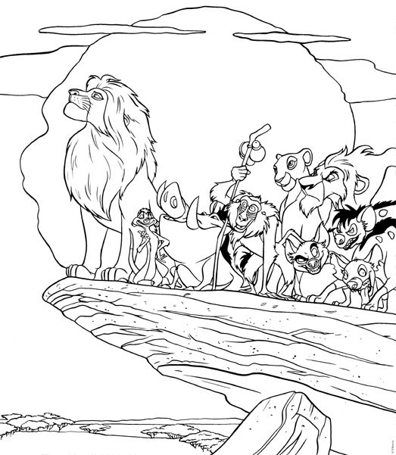
Name ___________________

1. Draw a food chain at least three members long consisting of living things in the movie.
---------> --------> -------->

2. Identify the producer, the Primary consumer, and Secondary consumer in the food chain.
3. A Balanced Ecosystem
Fill in the chart with living things found in and around Pride Rock. Put them in their proper group.
Producer | Herbivore | Carnivore | Omnivore
4. In the beginning of the movie Scar is about to eat a mouse. Identify the:
Predator______________ Prey _______________
5. When explaining the Circle of Life Mufasa says to Simba, "When we die our bodies become the grass." Name the process that Mufasa is referring to. _____________
6. During the song Oh I Just Can't Wait to Be King" the crocodile has birds in its mouth. This is a symbiotic relationship. What type of symbiotic relationship is it? __________
7. When Scar replaces Mufasa the pride's stable ecosystem is replaced by an unstable ecosystem. Describe three ways the movie indicates this change in the ecosystem.
a.
b.
c.

8. Give an example of a population from the movie.
9. Puma asks Simba, "What's eating you?" Timone jokes, "Nothing, he's at the top of the food chain!" What does Timone mean?
10. Who replaces Scar as the leader of the pride? _____________________

