Name: ____________________________
Tier 2 Organ Structure and Function

In order to take form C of the quiz, you must complete the following questions correctly.

- What is the function of the gallbladder?
- What is the function of the ovary?
- Label all the parts of the flower. 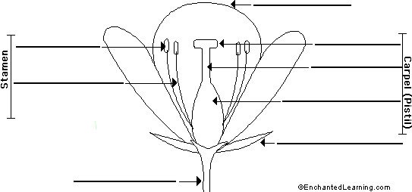

- Label the following with the correct name and function for what it represents. Glass tube, balloons, rubber sheet.
