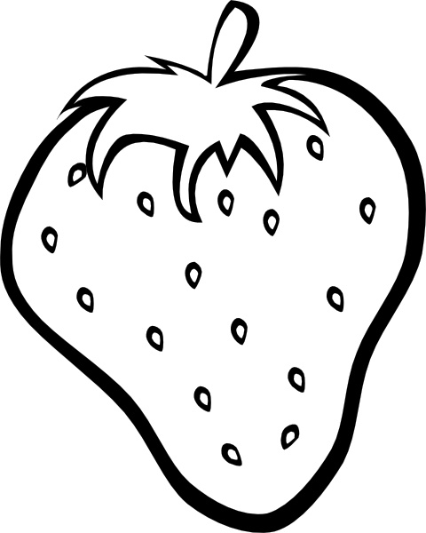
Strawberry DNA Extraction
57
Introduction: Have you ever wondered what DNA looks like? You are going to break apart the cell membrane of a strawberry and separate the DNA from the nucleus. Strawberries are a good source of DNA because they have 8 copies of each type of chromosome. This large number of chromosomes will filter out of your solution and you will get to actually see DNA.
Pre-lab Questions
- Where in the cell is the DNA found?
- What do you think the DNA will look like when you extract it from the plant cell?
Materials: Baggie, Cone Shaped Coffee Filter, Beaker, Plastic pipette
Available from your teacher: 1 Strawberry 10 mL DNA extraction buffer (50 ml soap, 1tsp salt, 450 ml water) 15 mL ice cold ethanol in test tube
Procedure:
- Place one strawberry in a zipper bag.
- Mash up the strawberry for 2 minutes.
- Add 10 mL of the extraction buffer to the bag.
- Mash again for 1 minute.
- Drape the coffee filter in the beaker. Make sure the top part of the filter is folded over the top of your beaker and that the bottom of the filter does not touch the bottom of the beaker.
- Pour the mashed strawberries with the extraction buffer into the filter and let drip into the bottom of the cup. This takes about 10 minutes.
As you wait for your solution to filter, complete the following questions:
Mid-lab Questions
- What was the purpose of mashing up the strawberry?
- What does the extraction buffer do? (Hint: Extraction buffer contains soap. What does soap do when you wash your hands?)
Once your 10 minutes is up….
- Get a test tube that contains ice cold ethanol.
- Using a pipette, remove some of the strawberry extract from the cup.
- Carefully pipette the strawberry extract into the alcohol in the test tube and watch the solution precipitate (separate). DO NOT SHAKE THE TUBE!!! Very gently swirl the tube once or twice. Then let the tube remain undisturbed.
- Watch where the alcohol and extract layers come in contact with each other. Keep the tube at eye level so you can see what is happening.

Post-lab Questions
- What do you see appearing? (draw a sketch in the box -->)

- What happened when you added the filtrate to the alcohol?

- What does DNA look like?

- A person cannot see a single cotton thread four classrooms away. But if you wound thousands of threads together into a rope, it would be visible at the same distance. How is this statement an analogy to our DNA extraction?

- Is DNA found in all living or once living cells?

- Since the strawberries were once living, and we extracted DNA from them, what does this mean about the foods you eat?

- Remember that genes are found on chromosomes, and genes control traits. Give at least two examples of traits that are expressed in the strawberry.

