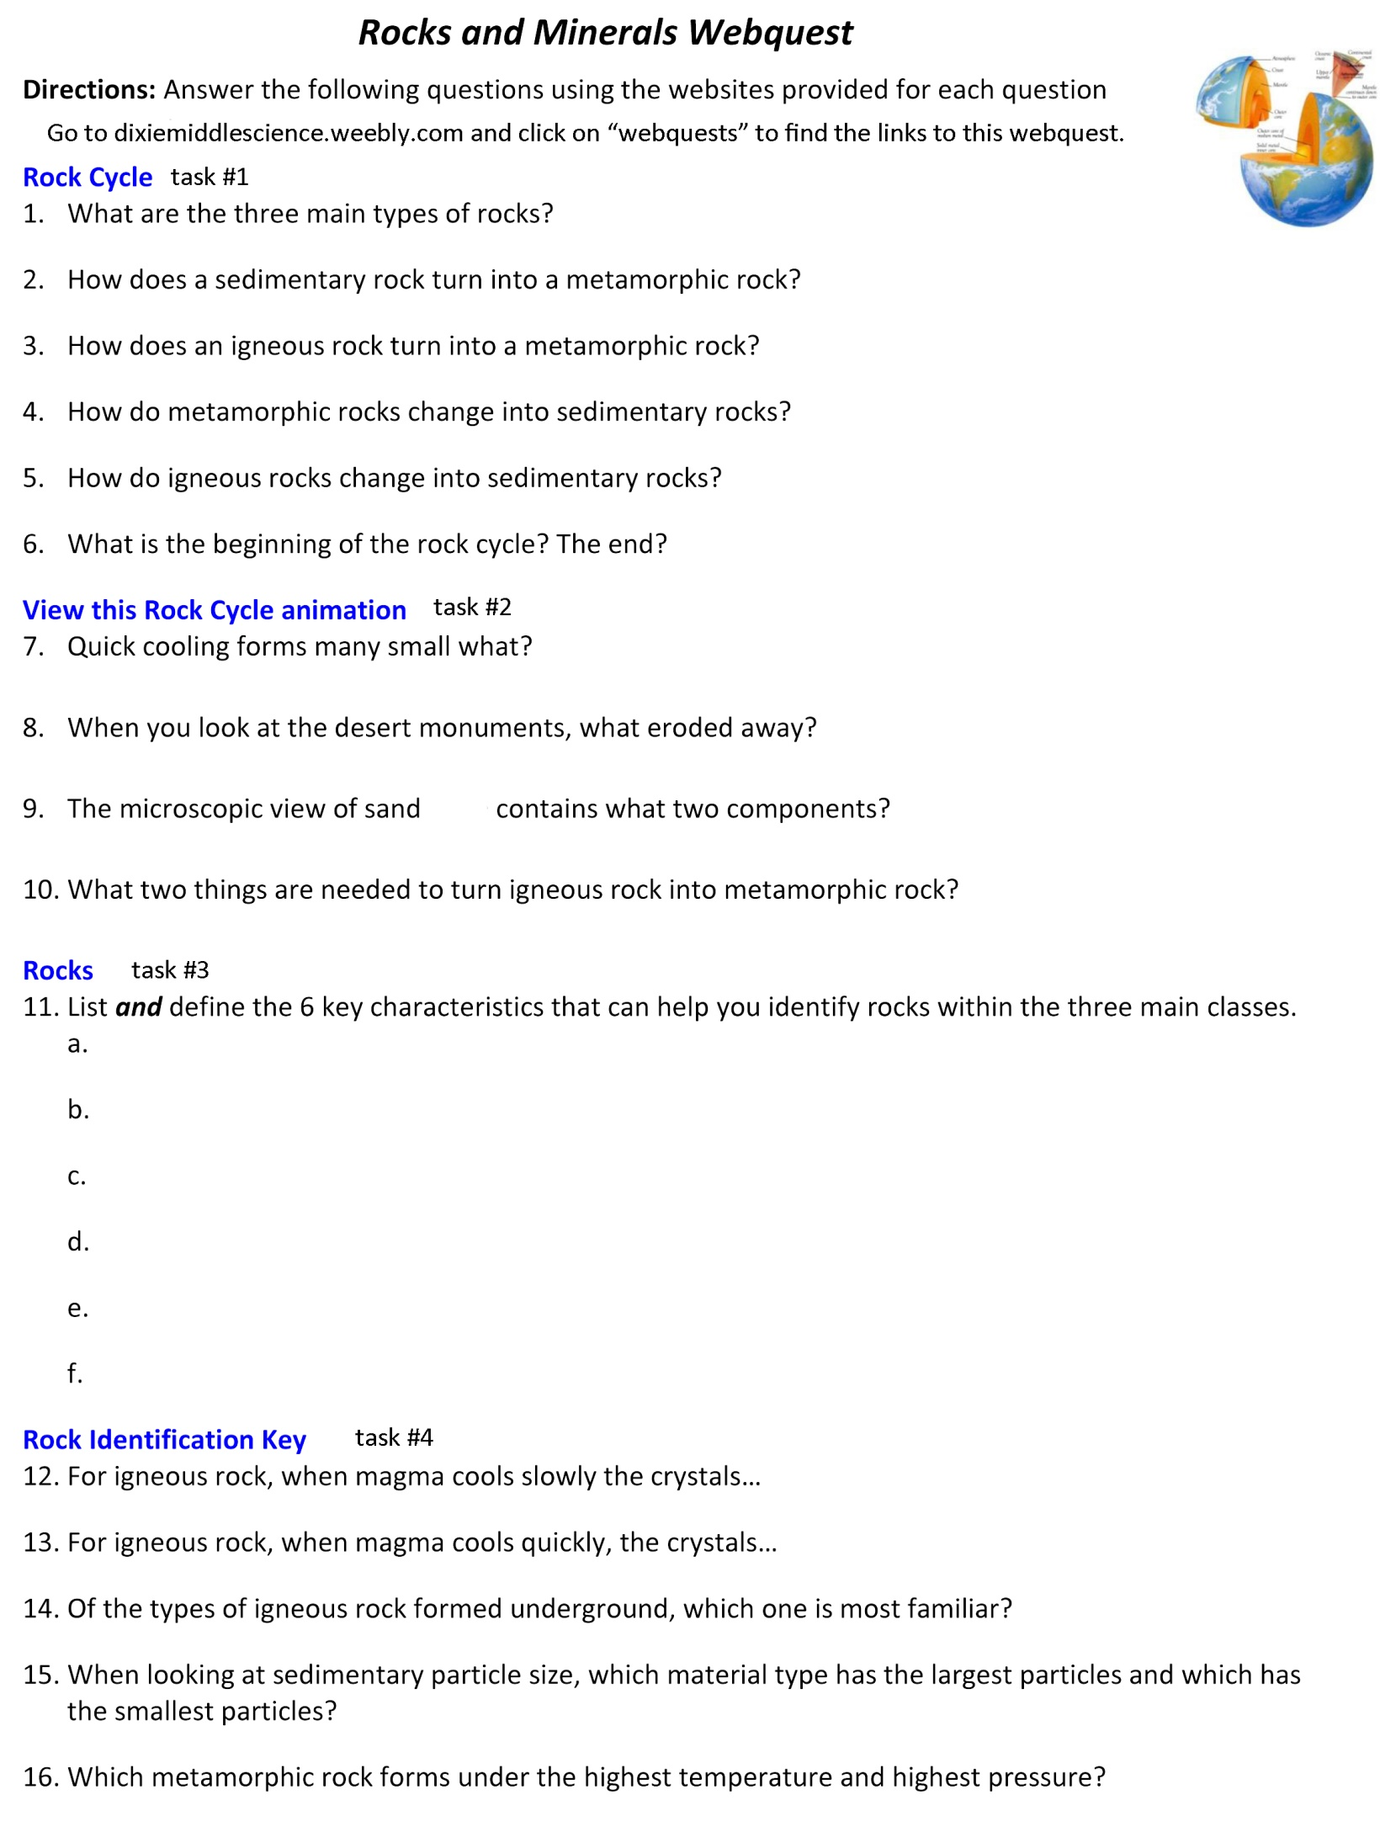

Name: _____________________________

