Remediation: Cells Webquest
WEBSITE #1
1. What is a CELL?
2. What does it mean to be UNICELLULAR?
3. Identify an organism that is UNICELLULAR: ____________________________
4. What does it mean to be MULTICELLULAR?
5. Identify an organism that is MULTICELLUAR: _________________________
WEBSITE #2:
1. There are two types of cells. PROKARYOTIC= ______________________
Eukaryotic= Plants and _______________________
2. What types of cells do YOU have (PROKARYOTIC or EUKARYOTIC)?_______________________________
3. Which type of cell is more complex (complicated)?___________________
4. Which type of cell is more simple? _____________________________
WEBSITE #3: Click start animation.
This is a picture of __________________which is a type of PROKARYOTIC CELL!
DRAW A ROUGH SKETCH OF THE BACTERIA BELOW:

WEBSITE #4:
CLICK ON the eukaryotic cell
CLICK ON start the animation, choose animal cell
Using the model IDENTIFY 5 cell parts:

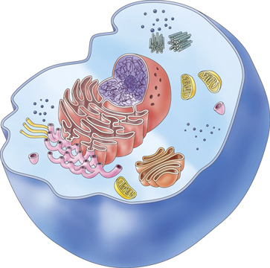

1. Click on CYTOSKELTON. What is the job of the CYTOSKELETON?
2. Which part of the cell surrounds the cell and allows molecules in and
out. This cell part also has holes in it and is said to be SEMI-PERMEABLE.
_______________________________
3. Which cell part contains DNA? ________________________________
4. Which cell part is the storage center for food and water!____________
Now go back and CLICK ON THE “PLANT CELL”. Again, IDENTIFY 5 cell
parts in the diagram below.
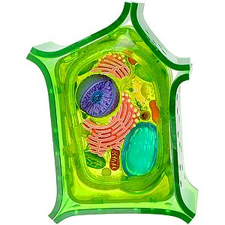
NOT ON THE WEBSITE: After observing both plant and animal cells. IDENTIFY
TWO DIFFERENCES between them!
1. ____________________________________________
2. ___________________________________________
Watch the video on the cell theory.
What are the 3 parts to the cell theory?
1.
2.
3.
Who named cells?

Why did he name them cells?

