Name: __________________________
Remediation: 3.2F 3.3ABCDE
Fossil or NOT?
Directions: Use the following definitions to help you determine if the items on the Fossil or NOT sheet are Fossils… or not. Then give a reason for each choice.
- Fossils are remains or trace of an ancient organism.

Item | Fossil or NonFossil | Reason
Walnuts
Carbonaceous Film
Coprolite
Dinosaur Bones
Mold & Cast
Petrified Wood
Ancient Pottery

List the 5 types of fossils and give examples of each:
1.
2.
3.
4.
5.

A distinctive fossil used to compare the relative ages of fossils is known as a(n)_______________ fossil.

What type of Rocks are Fossils found in?

Sequencing Sedimentary Rock Layers
List the steps in order from oldest to youngest .
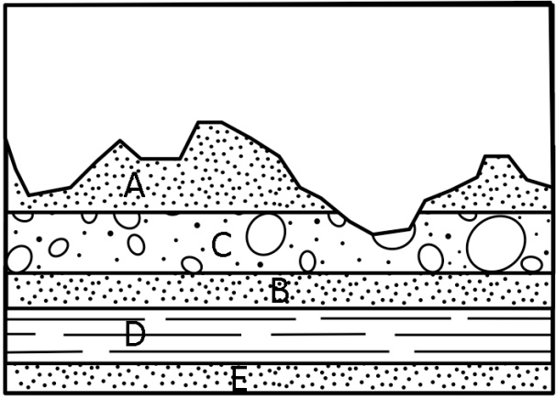 | Youngest  ________  ________  ________  ________  ________  Oldest | 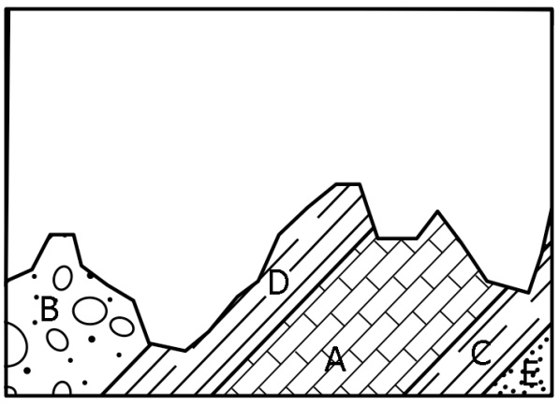 | Youngest  ________  ________  ________  ________  ________  Oldest
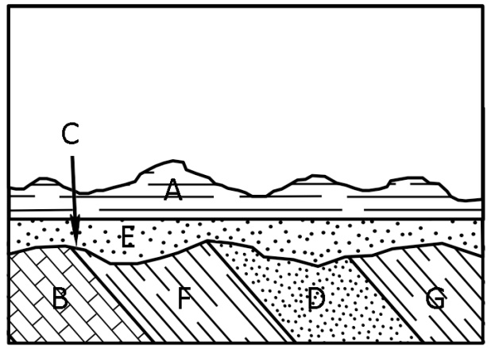 | Youngest  ________  ________  ________  ________  ________  ________  ________  Oldest | 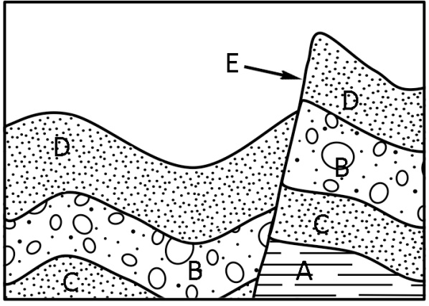 | Youngest  ________  ________  ________  ________  ________  Oldest
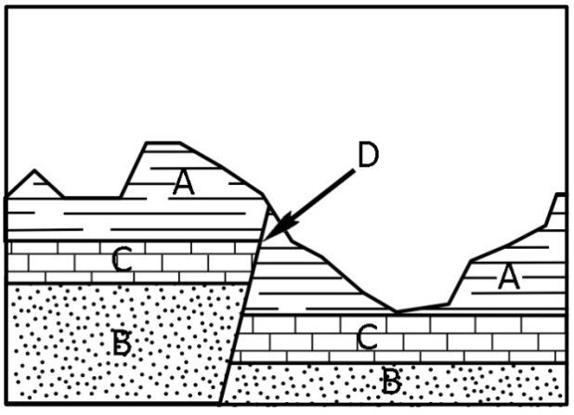 | Youngest  ________  ________  ________  ________  Oldest | 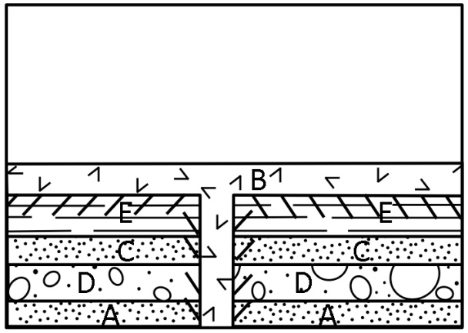 | Youngest  ________  ________  ________  ________  ________  Oldest
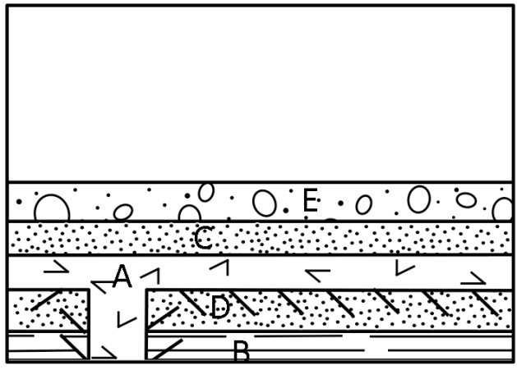 | Youngest  ________  ________  ________  ________  ________  Oldest | 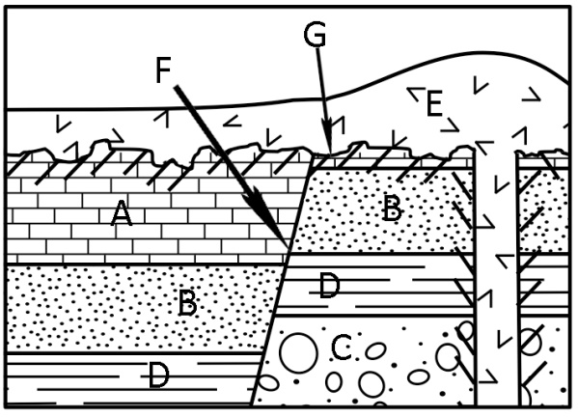 | Youngest  ________  ________  ________  ________  ________  ________  ________  Oldest

