Name: _________________________
Date: _____________

Remediation 4.1AB Waves
Video: Waves

1. Energy travels in _____________________.

2. _______________________ is how often waves pass by.

3. If you increase the frequency, the wavelength is _____________.

4. All waves have a similar ________________.

5. We SEE different wavelengths as different _________________.

6. X-ray waves are just like light waves, only they are much _________________ together.

7. Wavelength is the distance from the __________________________ of one wave to the ________________________ of another wave.

8. ____________________________ is the height of a wave.

9. What type of wave squeezes and spreads?

10. Sonar uses ___________________ waves to find stuff underwater.

Label the wave with the missing information:

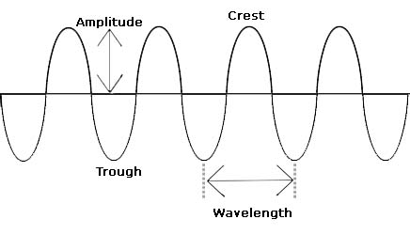

Label the following diagram with the missing definition:
