Name: _____________________

Remediation 2.1C 2.2 AB

All energy for life on Earth comes from the sun. After the energy leaves the sun it is used by plants on Earth where photosynthesis converts it to sugars. The plants store chemical energy that can be used by the plants, or converted into mechanical energy within an organism (e.g. an animal which eats the plant.) Photosynthesis is the process that explains how energy from the sun is captured by green plants and used to make food. Most of this energy is used to carry on the plant's life activities. The rest of the energy is passed on as food to the next level of the food chain.
- Where does all energy for life on Earth come from?
- Explain how we end up with mechanical energy that original came from light energy from the sun.

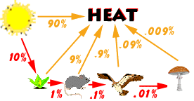
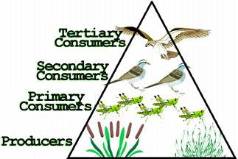
The figure at the left shows energy flow in a simple food chain. Notice that at each level of the food chain, about 90% of the energy is lost in the form of heat. The total energy passed from one level to the next is only about one-tenth of the energy received from the previous organism. This means that an animal eating a plant will only get about ten percent of the energy that is stored in the plant. The remainder of the plant's energy is unusable as energy by the animal. Therefore, as you move up the food chain, there is less energy available. Animals located at the top of the food chain need a lot more food to meet their energy needs.
- As energy is passed from one organism to another in a food chain, how much energy is lost?
- How much energy is really passed on from one lever of the food chain to the next?
Below are several food chains. Use the list of organisms provided for each food chain and place these organisms in order according to the flow of energy. Remember to begin with energy coming to Earth. The path should go from the original source to the last organism to use the energy. Each of the items in the list should only be used once on a line.
- Hawk
- Bunny Rabbit
- Sun
- Lettuce
1. ______________ _____________ _____________ ______________
- Snake
- Cricket
- Rat
- Seed
- Sun
- Eagle
2. ______ ______ ______ _______ ________ ______
- Sun
- Herbivore
- Carnivore
- Producer
- Top Carnivore
3. __________ __________ __________ ___________ _________
- Shrubs
- Sun
- Mountain Lion
- Deer
4. ______________ ______________ ______________ _____________
- Grass
- Cow
- Human
- Sun
5. ______________ ______________ ______________ ______________
