Pig dissection Pre-lab
82
1. Describe how you will tie your pig to the dissection tray.
2. Draw the lines that you will cut to begin your dissection.
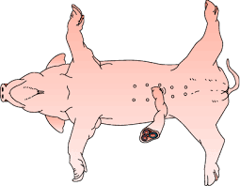

3. Will you cut around or through the ribcage?
4. Where is your diaphragm located? What organ system does it aid?

5. Once the pig was opened, what organs did you see?

6. What layer wraps around the heart for protection?
7. Describe how you will remove the liver.

8. What is the function of the liver?

9. Where will the gall bladder be located? What is its function.
10. What is the purpose of the spleen? Where is it located.
11. What color is the spleen? Why?
12. What is the function of the pancreas? Where is it found? What does it look like?

13. What is the function of the stomach?
14. What is the function of the small intestine?
15. How will you remove the stomach, spleen, and intestines?
16. Why are your intestines so long?
17. What shape are your kidneys? What is their function?
18. What is the purpose of your urinary bladder?
19. What was the purpose of removing the kidneys?

