Photosynthesis and Cellular Respiration Foldable
31
For this assignment, you are going to be making a 5-flap foldable for the cellular process of photosynthesis and cellular respiration. Use your webquest and reading guide for the needed information.
Set-up
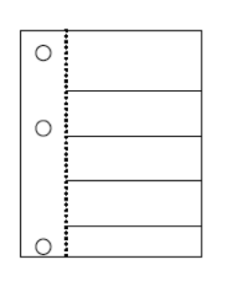
Hole punch your paper. Fold the right side of the paper over to the left side. Do not cover the holes. Section your paper to get 5 equal size flaps as seen in diagram. Cut along the lines you just folded ONLY to the center fold line.
Front Flaps
Label each flap following the order below:
o Organelle o Equation o Reactants in Equation o Production in Equation o Importance to Organism (must be 2 sentences)
Inside Back- Photosynthesis
Fill in the boxes following the prompt on the front flap for the process of photosynthesis.
Inside of the Flaps- Cellular Respiration
Fill in the boxes following the prompt on the front flap for the process of cellular respiration.

