Name_________________________
66
Period_____________
Organisms UNIT
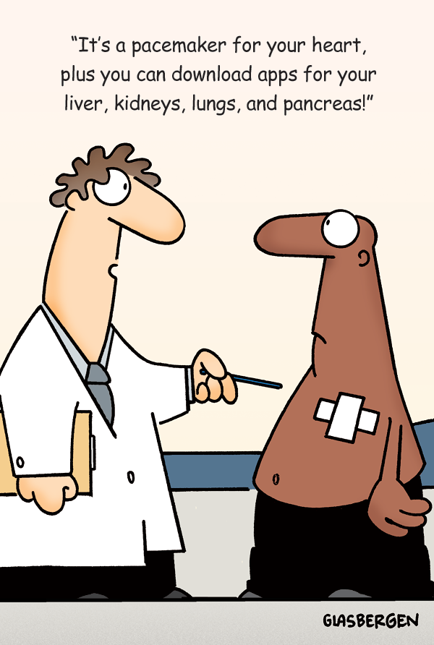
GVC: Students will understand the relationship between structure and function of organs and organ systems.

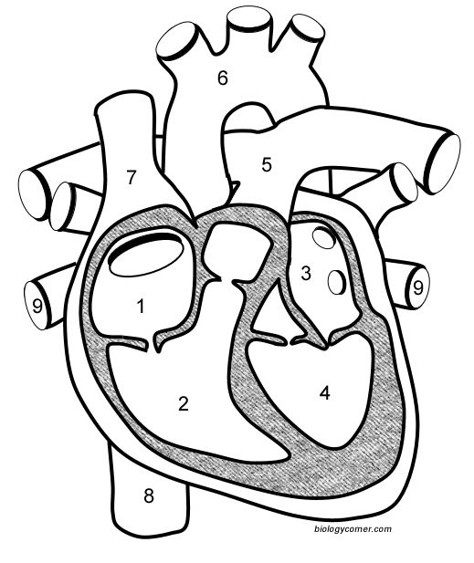

Label each of the parts of the heart and associated vessels that are numbered.
Word Bank
superior vena cava
inferior vena cava
aorta
pulmonary artery
pulmonary veins
left atrium
left ventricle
right atrium
right ventricle

