Mitosis Flipbook
Create a flipbook to illustrate the phases of Mitosis.
The front should look like this… (Decorate as you wish)
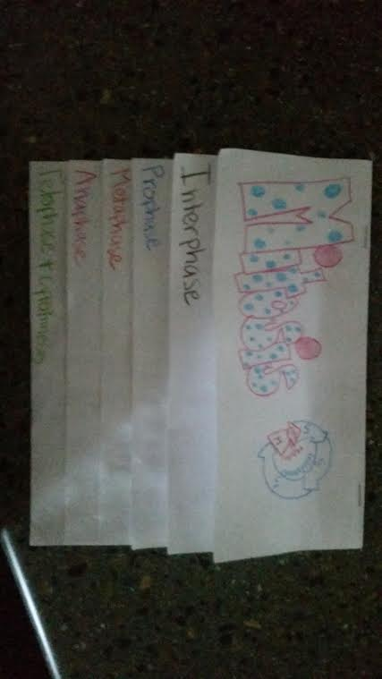
Inside flaps should look like this…
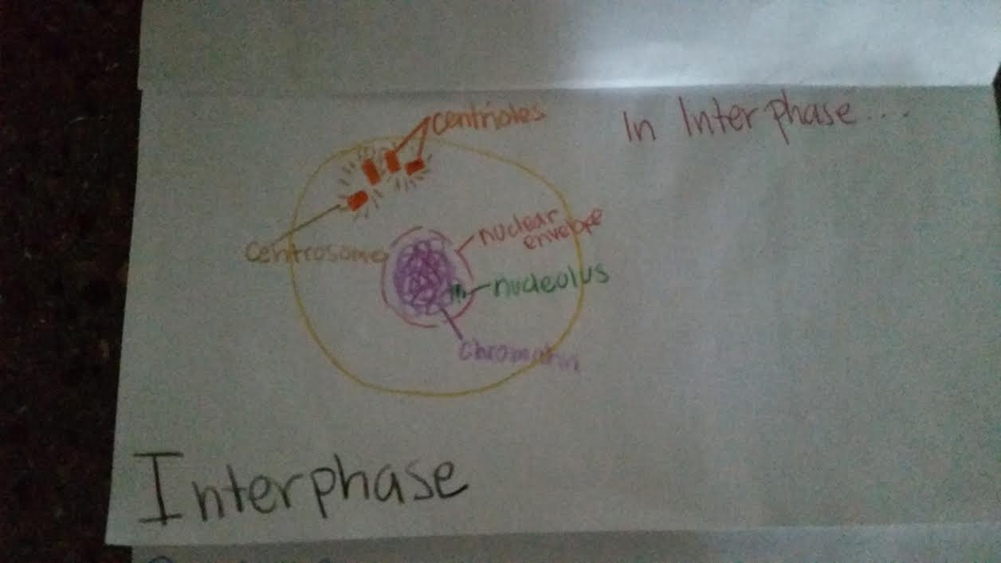
- Colored (keep the same color for each organelle throughout the flipbook)
- Label organelles involved in phase
- Write a description of what is happening in that phase

