Lab- Photosynthesis
32

Leaf disks float, normally. When the air spaces are infiltrated with solution the overall density of the leaf disk increases and the disk sinks. The infiltration solution includes a small amount of Sodium bicarbonate. The bicarbonate ion serves as the carbon source for photosynthesis. As photosynthesis proceeds oxygen is released into the interior of the leaf which changes the buoyancy--causing the disks to rise. Since cellular respiration is taking place at the same time, consuming oxygen, the rate that the disks raise is an indirect measurement of the net rate of photosynthesis.

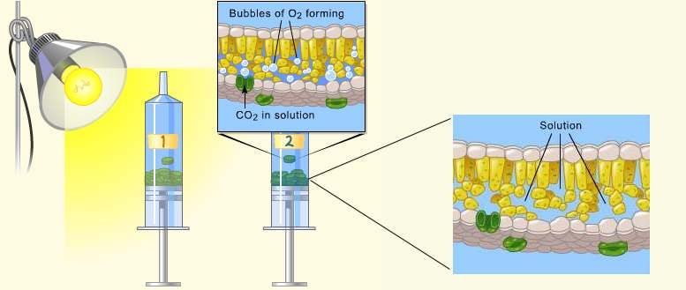

Materials:
- Sodium bicarbonate (Baking soda)
- Liquid Soap
- Plastic syringe
- Spinach Leaf
- Hole punch
- 2 Beakers
- 2 Plastic cups
- Timer
- Light source

Pre lab: The bicarbonate serves as an alternate dissolved source of carbon dioxide for photosynthesis. Do one prelab per table!
- Prepare a 0.2% solution. (This is not very much it is only about 1/8 of a teaspoon of baking soda in 300 ml of water.)
- Add 1 drop of liquid soap to this solution. The soap wets the hydrophobic surface of the leaf allowing the solution to be drawn into the leaf. Avoid suds! If your solution generates suds then dilute it with more bicarbonate solution.
- Obtain a second beaker and add 1 drop of liquid soap. Fill the beaker with 300 ml of tap water. Avoid suds! This is your control.
Procedures:
- Cut 20 uniform leaf disks (10 for experimental, 10 for control).
- Infiltrate the leaf disks with sodium bicarbonate solution.
  - Remove the plunger and place the 10 leaf disks into the syringe barrel. Replace the plunger being careful not to crush the leaf disks. Push on the plunger until only a small volume of air and the leaf disks remain in the barrel.
- Pull a small volume of sodium bicarbonate solution into the syringe. Tap the syringe to suspend the leaf disks in the solution.
- Holding a finger over the syringe-opening, draw back on the plunger to create a vacuum. Hold this vacuum for about 10 seconds. While holding the vacuum, swirl the leaf disks to suspend them in the solution. Let off the vacuum. The bicarbonate solution will infiltrate the air spaces in the leaf causing the disks to sink. You will probably have to repeat this procedure 2-3 times in order to get all the disks to sink.
- Pour the disks and solution into a clear plastic cup labelled “sodium bicarbonate (experiment)”. Divide the remaining bicarbonate solution between the two groups at your table.
- Rinse the syringe.
- Repeat steps 2-5 for the remaining 10 leaf disks, this time infiltrate with your water solution and split the remaining water solution between the two groups at your table. Your new cup should be labelled “water (control)”
- EACH GROUP SHOULD NOW HAVE 2 CUPS WITH 10 LEAF DISKS IN EACH. ONE LABELLED “SODIUM BICARBONATE (EXPERIMENT)” AND ONE LABELLED “WATER (CONTROL)”
- Place both cups under the heat lamp and start your timer. At the end of each minute, record the number of floating disks. Then swirl the disks to dislodge any that are stuck against the sides of the cups. Continue until all of the disks are floating. Then make a plotted graph of your results.
- Do three trials, you will need new infiltrated leaf disks for each trial.
Data: Sodium Bicarbonate (experimental) Water (control)
Time (minutes) | Trial 1 | Trial 2 | Trial 3 | Average
1
2
3
4
5
6
7
8
9
10
Time (minutes) | Trial 1 | Trial 2 | Trial 3 | Average
1
2
3
4
5
6
7
8
9
10

Graph: Disks Floating vs. Time
Questions:
1. What purpose did the soap serve in the solution?

2. What gas was forming and making the disks rise?

3. What chemical energy processes where happening in the disks?

4. How long did it take for all of your disks to rise?

5. What else could you test for and graph if you were to do an extension of this lab.

