Station 1

Echolocation
A lot of animals use echolocation to both navigate and hunt. They send out high-frequency sounds and use the returning echoes to form “images” of our environment. As if by singing, almost, we could see.
Also known as biosonar, this is a gift bestowed upon animals like bats, but also toothed whales and dolphins, as well as (in simpler form) shrews and some cave-dwelling birds. But it doesn’t stop there, other organisms echolocate with electrical impulses. They broadcast from their bodies like electric fish and electric eels. Humans have no sense of echolocation whatsoever and yet bats, for example, can maneuver with fantastic speed and accuracy just using echo locations from their own voices.
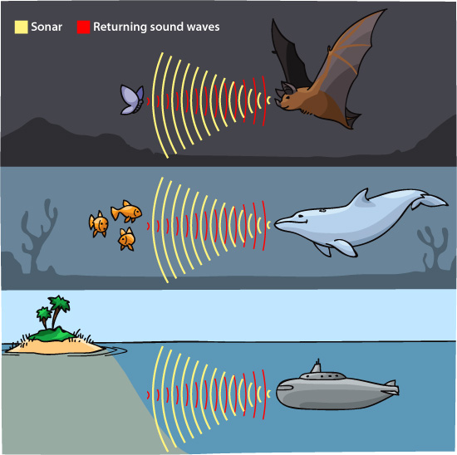

Station 2

Magnetic fields
While science tells us all about Earth's magnetic field, a large number of animals can actually sense it, and they use it to their advantage all the time.
There have been a number of experiments showing that organisms from hamsters, salamanders, sparrows, and rainbow trout to spiny lobsters and bacteria employ the magnetic field.
Dogs use an internal magnetic compass to guide pooping orientation, salmon use it to navigate the ocean, and even cows tend to face either magnetic north or south when grazing or resting.
Sadly for us humans, there’s no scientific evidence that we have this “sixth” sense. We have GPS instead.
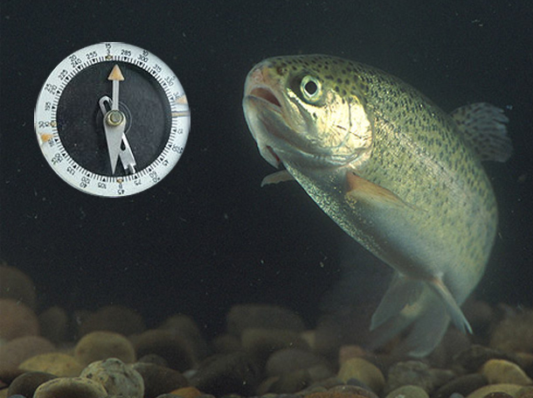

Station 3

Pheromones
While humans live in a world mostly dominated by sight and sound, other organisms live in existence based on smell – specifically by means of pheromones. These chemical smells communicate everything from stress and alarm to danger and potential mates. Ants are the poster children for this phenomenon. They have 10 to 20 substances that they use to smell and taste in organizing their society. We just see ants running around; they look like they're little particles in movement or forming lines and so on. The way they release those pheromones is like forming sentences. With pheromones, ants say: pay attention; come in this direction; a problem; a situation; opportunity; come; attack, attack, attack; step aside; help clean it. “It just goes on forever.”
Bacteria, other insects and various mammals live in a sea of pheromones that we have little capacity to grasp. We live, all the time, especially in nature, in great clouds of pheromones. We're just beginning to understand how the natural world works. And a large part of it is that it lives in another world from the one we do, the pheromone world.

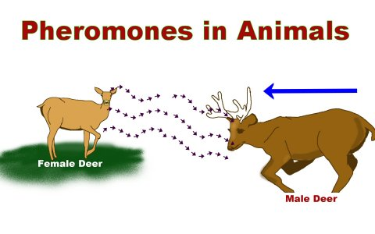
Station 4

Electromagnetic spectrum
We think we see everything, but we only SEE a tiny section of the electromagnetic spectrum.
Other creatures “see” other parts of the spectrum. Pollinators like bees and butterflies have the ability to see ultraviolet which helps them navigate into a flower’s sweet spot. Where we see a collection of yellow petals on a flower, a bee sees a bull's-eye pattern that tells them exactly where to aim.
Meanwhile, pigeons can see different shades of the same color; this includes wavelength that differs by only a few billionths of a meter. Humans can only sense 3 different spectral bands; pigeons can sense as many as 5 different spectral bands.
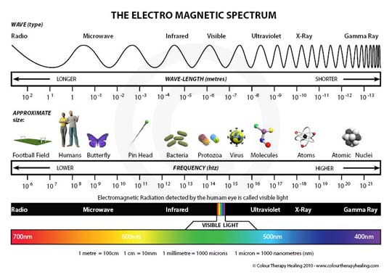

Station 5

Plant Responses to Light
Plants have a lot more uses for light than just photosynthesis. Plants can develop in response to light (known as photomorphogenesis), which allows plants to optimize their use of light and space. Plants use light to track time, which is known as photoperiodism. They can tell the time of day and time of year by sensing and using various wavelengths of sunlight. Light can also create a response in plants that allows them to grow toward, or even away from, light; this is known as phototropism .

Phototropism of an orchid plant
This orchid plant placed next to a window grows toward the sunlight through the window. This is an example of positive phototropism.

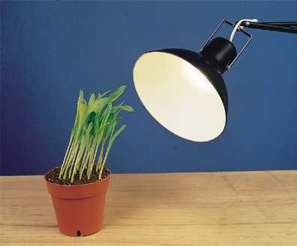
Station 6
Human Eye Dilation
If you’ve ever stayed up late at night with friends, you may have noticed something peculiar about their eyes. Have you ever noticed that your eyes seem to look bigger in the dark?
To learn why this happens, we need to know a bit more about the eye itself. The outer part of your eye that you can see and feel is called the cornea. Just behind the cornea sits the iris, a circular membrane that gives your eyes their color.
The iris plays an important role in the proper functioning of the eye. Its job is to control the amount of light that enters the eye through your pupil, which is the opening in the middle of the iris that looks like a black circle.
Why is this role so important? Like a camera depends upon light to capture vivid images, your eyes depend upon the correct amount of light to see properly. During the day, less light is needed to see the things around you. At night, however, more light is usually needed to see things you might have seen easily during the day.
To control the amount of light entering the eye, the iris widens or narrows to change the size of the pupil. For example, when it’s dark, the iris widens and the pupil dilates, or gets bigger, to allow as much light as possible to enter the eye.
The opposite occurs during the day. When the Sun is shining bright, the iris narrows and the pupil constricts, or gets smaller. This restricts the amount of light entering the eye, allowing only enough light to see properly.
The amount of light can vary wildly throughout the day and into the night. Your pupils respond and react accordingly as light levels fluctuate. The size of the pupil can change in size from as little as 1.5 millimeters to over 8 millimeters in diameter.
In addition to controlling the amount of light that enters the eye, your pupils can also change size in response to emotional stimuli. If you’re mad or afraid or even in love, your pupils can change in size as your body feels these emotions.
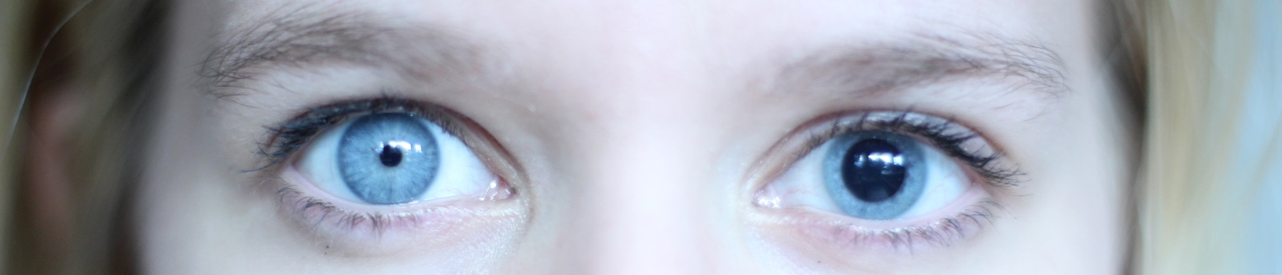

Station 7

Hibernation
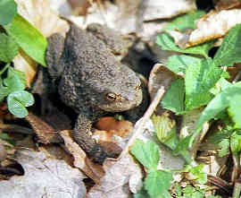
For most animals finding enough food in winter can be difficult when the main source of food like insects or green plants is in short supply.
Some animals solve this problem by hibernating. Hibernation is a deep sleep that helps them to save energy and survive the winter without eating much.
During hibernation the animal’s body temperature drops, and its heartbeat and its breathing slow down so that it does not use much energy.
Hibernating animals get ready for their winter sleep by eating extra food and storing it as body fat which they then use as energy while sleeping.
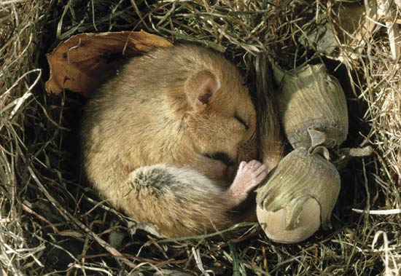
Some of the hibernating animals include fish, frogs and turtles, which have no way to keep warm during winter. They shelter under logs, rocks and fallen leaves in the water. When the weather gets cold, they move down to the bottom of lakes and ponds and some even burrow into the mud.
Some insects also hibernate and to keep warm they find holes in the ground, under tree bark or in rotting logs.

Station 8
Can you hear that?
Dogs have much more sensitive hearing than humans, hearing sounds four times farther away than we can. They can hear higher frequency sounds, can more easily differentiate sounds (e.g. they may recognize the sound of your car) and they can pin point the exact location of the sound.
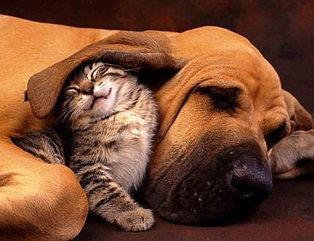
Sound is caused by air vibrations. The more vibrations per second, the higher the sound and the higher the frequency. Humans cannot hear sounds that vibrate at greater than 20,000 vibrations per second (20,000Hz) Dogs can hear sounds of up to 50,000 vibrations per second (50,000Hz). A dog whistle usually emits sound at greater than 20,000 Hz which explains why dogs respond to a dog whistle while it appears silent to us.
So why do dogs hear better than humans? The ears of dogs are controlled by up to 18 muscles while humans are equipped with only six and can only move their ears slightly, if at all.

Other animals can hear at different frequencies:
  - Elephants hearing range is between 1 and 20,000 Hz. The very low frequency sounds are in the “infrasound” range. Humans cannot hear sound in this range.
  - Mice can hear frequencies between 1,000 and 100,000 Hz.
  - Cats can hear frequencies between 30 Hz and 65,000 Hz.

