Lab-GEL ELECTROPHORESIS OF DYES

62B

In this experiment you will be using electrophoresis to separate dye samples which have different sizes and charges of molecules.

**Pre-lab (this has been done for you)**

1. Seal each end of the gel tray with masking tape. Place the plastic comb into the middle of the tray. Go to the hot water bath and get the bottle of melted agarose.

2. Carefully pour the agarose into the gel tray until it is approximately 1/3 of the way up the teeth of the comb. Make sure that there are no bubbles in the gel.

3. Let the gel harden without disturbing it for about 20 minutes.

4. Carefully remove the comb from the gel by pulling straight out of the solidified gel. Remove the tape from the ends of the gel tray.

**Procedure**

5. Place gel into electrophoresis unit. Add buffer to completely cover the top gel surface with about 2 mm of buffer (just above the gel).

6. Load 5-10 µl (microliters) of each dye into 6 different pipettes. You will use the same plunger for all colors so make sure you rinse it in between colors.

7. On the diagram below, make a key using colored pencils that you will use to remember which dye you have placed in each well.

**Name of dye**

_____________________________



_____________________________

_____________________________

_____________________________

_____________________________

_____________________________

8. Carefully load the dyes into the wells of the gel. See diagram on right.

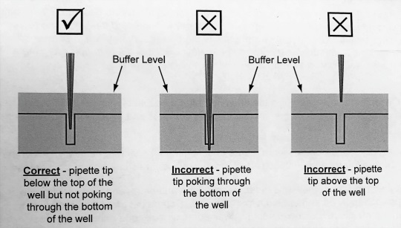9. Clean up any spilled buffer or any other liquid surrounding the gel box thoroughly.

10. Make sure that the power supply is unplugged before proceeding.

11. Carefully place the lid on the gel box and connect the terminals correctly.

12. Plug in the power supply (batteries)

13. Observe the tiny bubbles that form along the platinum electrodes.

14. Let the gel run undisturbed for about 30 minutes but check frequently to determine that the dyes will not run off the end of the gel into the buffer compartment.

15. When the dyes reach approximately 1 cm from the end of the gel, turn off the power supply. Disconnect the cords from the power supply.

16. Complete the diagram below using colored pencils to show your results.



**Clean up**

17. Rinse all pipettes and plungers and return to the front of the lab. Gels may be placed in the trash.

18. The electrophoresis chamber, tray and comb should be rinsed in water and then allowed to air dry. Be very careful not to damage the tiny electrode wires at each end of the gel box. Wash your hands thoroughly and clean the area where you were working. Return all materials to their original location.

**Analysis Questions:**

1. Why is the comb placed in the center for this electrophoresis experiment?

3. Which dye likely contained the smallest molecule?

4. How do we know this?

5. What dyes are in the mixture?