Evidence of Evolution
97
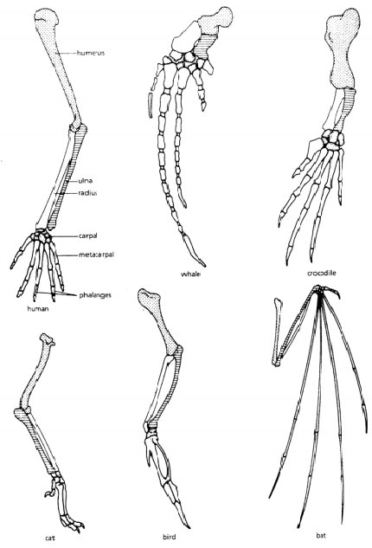
Much evidence has been found to indicate that living things have evolved or changed gradually over time.
- Carefully examine the drawings of the bones to the right and look for similarities among the various animals. Color each part of the human arm a different color , then color the corresponding bone in each of the other animals the same color as the human bone.

- How are these bones arranged in a similar way in each animal?

Animal | Function
Human (arm/hand)
Whale (fin)
Crocodile (arm/hand)
Cat (arm/paw)
Bird (wing)
Bat (wing)
- Describe the function of each set of bones in the table below.

- Structures that are formed in similar ways during development and share like arrangements but have different forms and functions are (circle one) ANALOGOUS/HOMOLOGOUS

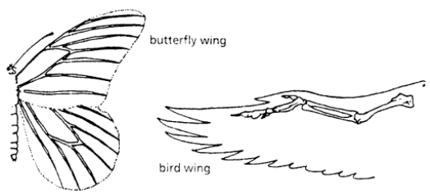
- Examine the butterfly wing and the bird wing to the right.
What function do these structures share?

- How do the two wings differ in structure?

- Do birds and insects share any structural similarities that would suggest they are closely related to each other?

- Some apparently unrelated animals have organs with similar functions, yet are very different in structure and form. These structures are called (circle one) ANALOGOUS/HOMOLOGOUs
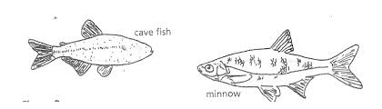
- The cave fish and the minnow are related, but the cave fish is blind. Explain why eyesight is not an important adaptation to life in a cave.

- Does the appearance of the cave fish and minnow suggest common ancestry? Why or why not?

- Organs or structures that have lost their function in the organisms are called _______________ .

- Read the list of human vestigial structures in the table and suggest a possible function for each structure and explain why it became vestigial.
Structure | Possible Function | Why Vestigial?
Appendix
Coccyx (tail bone)
Muscles that move ears
Muscles that make hair stand up
Little Toe
Wisdom Teeth

Analysis Questions:
- Explain why homologous structures are evidence of evolutionary relationships.

- Explain the evolutionary relationship between the fin of a fish and the flipper of a whale.

- List 2 structures (not from the table above) that you think are vestigial and explain why.

