Ecology Review
137
GVC 1- Students will understand that living organisms interact with one another and their environment.
1. Draw a 4 step food chain; include a producer, primary consumer, secondary consumer, and decomposer.

2. Which direction does energy flow in your food chain?
3. Place the organisms from your food chain in the energy pyramid. Label the trophic levels. Label each role in the food chain(Producer, etc.). Suppose the producers have 12,500 kcal of energy available to them, write the approximate available energy available at each level of the pyramid.
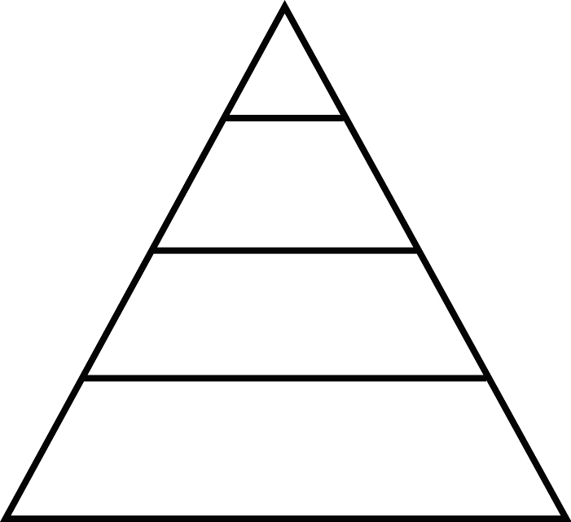
4. Write the path of energy from the sun to a person walking.
&
5. Give 2 examples of strategies organisms use to balance the energy expended to obtain food to the energy gained from that food. (Ex: Switching to a new prey.)
6. Give an example of each of the following Symbiotic relationships
Predatory/Prey
Competition
Mutualism
Commensalism
Parasitism

Give an example of an organism obtaining food. Example: Humming Bird hovers over a flower eating nectar.  7. | Compare the energy gained from that food to the energy expended obtaining that food.

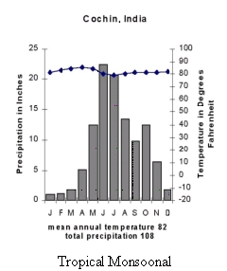
8. You are conducting an experiment to determine the effect of water temperature on the activeness of the fish in a freshwater pond.
- Write a hypothesis for your experiment.
- What is the independent variable?
- What is the dependent variable?
9. Use the graph to the right. During what months would you expect to see the most plant growth? Why?

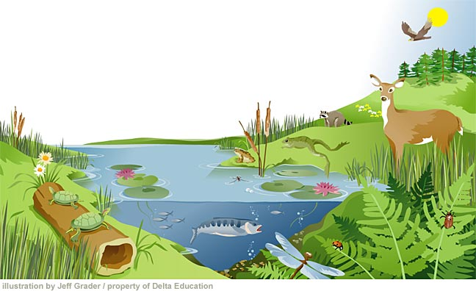
10. Using the picture below. List one qualitative observation for the ecosystem and one quantitative.

11. Why would loss of diversity in an ecosystem be a concern?
12. Explain how water is a limiting factory in some ecosystems.
13. Describe the difference between inference and evidence
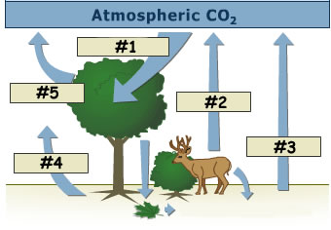
14. Label the picture to the right.

