Classification Reading Guide Part 2
108
Use pages 272-283 in your “bee” textbook.

- Animals range from simple ____________ to complex _______________.
- List and describe the animals included in the 9 major animal phyla.
1.
2.
3.
4.
5.
6.
7.
8.
9.
3. What is an invertebrate?
Give an example:
- What is a vertebrate?

- Give an example:

- How old is the oldest animal fossil?

- Fill in the major events on the Geologic time scale. 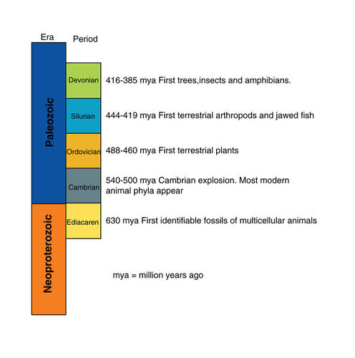
- Who were the ancestors of the earliest animals?
- List 6 important animal adaptations that came from invertebrates.

- What is an exoskeleton?

- How was this helpful when evolving from water to land?

- What is a notochord?

- What did the notochord evolve into in vertebrates?

