Cells Review
134
GVC 2- Students will understand that all organisms are composed of cells that are made of molecules, come from pre-existing cells, and perform life functions.
1. Lists the major chemical elements in cells.
2. What are trace elements? Give an example.
3. List and describe the function of the 4 macromolecules.

4. What is an “ORGANIC” molecule?
5. List and describe 4 properties of water.

6. What is the different between a solvent and a solute? (In a solution)
7. What is the importance of maintaining homeostasis in the body?
8. ____________ are protein molecules with specific shapes and functions. 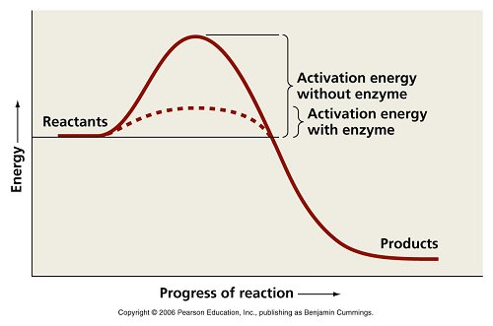
9. Based on the graph above, what do enzymes do to assist reactions?
10. What distinguishes autotrophic cells from heterotrophic cells?
11. What is the purpose of photosynthesis?
12. Photosynthesis equation:
13. What is the purpose of cellular respiration and fermentation?
14. Cellular Respiration equation:
15. Label the reactants/products in the above equations.
16. Where do cells come from?
17. How are theories such as “The Cell Theory” developed?
18. Describe osmosis.
19. Describe diffusion.
20. Describe active transport.
21. Label the cell (nucleus, nucleolus, mitochondria, centriole, golgi body, smooth ER, rough ER, nuclear envelope, plasma membrane, lysosome, cytoplasm, ribosome)
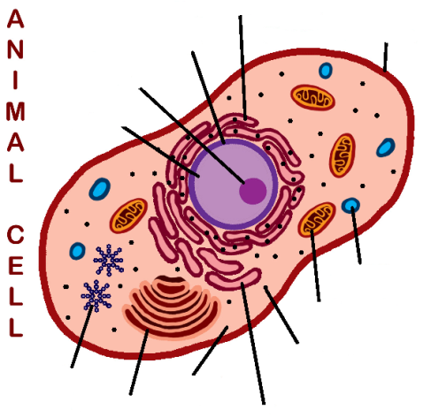
22. What additional organelles would be present if the cell pictured above were a plant cell?
23. What is the name for sex cell division? How many cells does this process start with? How many does it end with? List the steps. List 2 things that are unique about this process.

24. What is the name for mitotic cell division? How many cells does this process start with? How many does it end with? List the steps. List 2 things that are unique about this process.

