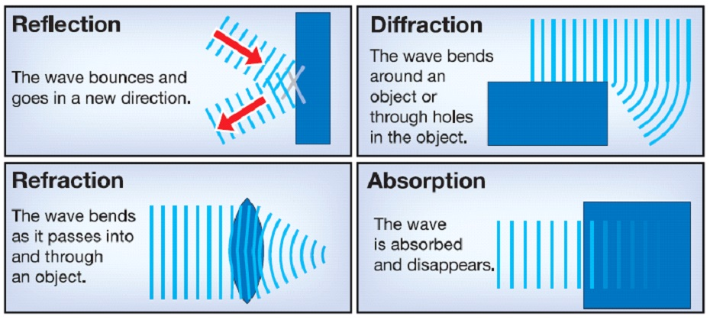
Behavior of Waves Lab
Name:_____________________
Period:_________________

Lab 1. Reflection
Materials: Ball, wall, protractor, ruler
Procedure:
- You will roll the ball into a designated spot on the wall in the lab.
- Roll the ball to the spot straight on. This is the “normal” line or Angle of Incidence.
- Roll the ball from each point…. A, B, and C.
- Draw the reflection of each line and label it A¹, B¹, and C¹.
Wall

normal A B C
Reflection Data:
Ray | Angle of Incidence  (Angle from Normal to Each letter) | Angle of Reflection  (Angle from each letter to its reflection)
A
B
C

Reflection Questions:
- How does the angle of reflection compare the corresponding angle of incidence?

- How would the information you learned from this lab, improve a person’s pool game?

Lab 2. Diffraction
Diffraction investigation
- Go to http://www.acoustics.salford.ac.uk/feschools/waves/diffract.htm
- Using the animations on-line investigate how waves are diffracted.
- Be sure to include detailed drawings and labels.
- Complete the online questions.

Light Wave – How do light waves behave around corners? (Draw what you observe.)
- Describe how a light wave behaves around a corner. How does size affect the wave?
________________________________________________________________________________________________________________________________________________________________________________________________________________________________________________________________________________________________________________________________________________________________________________________________________________________________
Sound Wave – How do sound waves behave around corners? (Draw what you observe.)
- Describe how a sound wave behaves around a corner.
________________________________________________________________________________________________________________________________________________________________________________________________________________________________________________________________________________________________________________________________________________________________________________________________________________________________

Barriers– How do waves behave when they encounter a barrier in a ripple tank? (Draw what you observe.)
Large Object | Medium Object | Small Object
- Describe how waves behave in a ripple tank when they encounter a barrier.
________________________________________________________________________________________________________________________________________________________________________________________________________________________________________________________________________________________________________________________________________________________________________________________________________________________________
Lab 3. Refraction
Refraction is the bending of a wave when it enters a medium where its speed is different. The refraction of light when it passes from a fast medium to a slow medium bends the light ray toward the normal to the boundary between the two media.
Materials: 2 beakers, 2 straws, water, and corn syrup
Place a straw into the water and let the handle rest on the side of the beaker. Look into the glass from the side and describe what happened to the straw.
Draw your observations of the side view of the beaker, straw and water

Why did that happen?

Place the other straw into the corn syrup. Look into the glass from the side and describe what happened to the straw.
Draw your observations of the side view of the beaker, straw and corn syrup

How is refraction the same between the water and corn syrup?

How is refraction different between the water and corn syrup?

What do you think would happen to the straw of it was place in a beaker of vegetable oil?

In your own words, explain refraction.

Lab 4. Absorption of Waves
Absorption is the process by which matter or waves are taken up internally by another object. Matter that is absorbed can be a gas, liquid, or solid. Radiation energy includes light, heat, X rays, ultraviolet rays, radio waves, and sound. Examples of the absorption of matter occur in everyday experience, like a sponge. It is a porous solid that will absorb water and other liquids.
Materials: flashlight and gummy worm
Start by laying the gummy worm on the white piece of paper on the table. Make sure it is straight as possible.
Turn the light on and place it at one end of the worm. Focus the light on just one color.

Did the light on the other side of the worm stay white like the flash light? Why or why not?

Now slide the light across the worm to the next color.
Did the light stay the same color? Why or why not?

Continue sliding the flashlight across the gummy worm. Explain what happens to the color of the light.

List three different situations where absorption occurs in nature.

