Write the correct number next to the corresponding label. 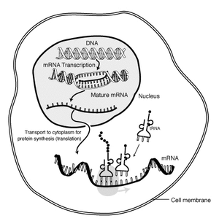
8
7
6
3
5
2
4
1

- Transcription _____
- Translation _____
- DNA ____
- mRNA ____ (2 answers)
- Nucleus ____
- Cell Membrane ____
- tRNA ____

What is the purpose of this process?

