Name: Period:
2
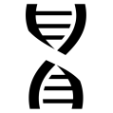Short Film: The Double Helix 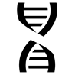
Driceitnos: As you wcath the flim asnewr the qeutsoins up to the pusae pinot. Srahe and dcsisus yuor aenrws wtih yuor tlbae, tehn the casls.
1. (4:08) What are the chromosomes made of?
Where are genes found?
What is the structure of DNA?
Why was Oswold Avery’s work significant to Watson and Crick?

2. (9:05) Why was x-ray crystallography being used to determine the structure of DNA?

3. (13:50) What is the structure of DNA?

What were the key pieces of evidence that led Watson and Crick to determine that structure?

4. (16:53) How does DNA’s structure explain the stability of life?

How does it explain the mutability of life?

