Chemistry of Flubber! Name:______________________#____
- Is Flubber an example of matter? Why or why not?
- What did the Professor use as a catalyst for his Flubber experiment?
- What was the Kelvin temperature of the Flubber when it was first discovered?__________ K
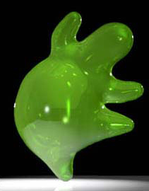
- In which state of matter is Flubber?
- List at least 3 physical properties that the Professor describes of his newly discovered Flubber:

- What two-word description did Weebo and the professor use before they thought of the name Flubber? __________________ ______________________
- Explain why a flash of green light might cause the Flubber to become so energetic.

8. What type of isotope was used to give energy to the Flubber? Natural or Radioactive
9. What was the type of radiation? Alpha, Beta , or Gamma
10. How many milligrams did the professor add to the hand cream in the golf ball experiment?
11. What is the name and chemical formula for the gas that caused the professor’s voice to change?
12. Why was the hand cream used as a separating agent when the Flubber was handled?
13. Flubber was a type of polymer. Define “polymer.”
14. Name 3 common polymers that really exist.
15. How did your understanding of chemistry from this unit help you to understand aspects of this movie?

