Name: ____________________________
Tier 2 DNA and Protein Synthesis

In order to take form C of the quiz, you must complete the following questions correctly.

- What chromosomes designate a male? A female?

- Write the steps for protein synthesis from DNA to Protein.

- Give an example of genetic engineering.

- What is the amino acid for GAG?
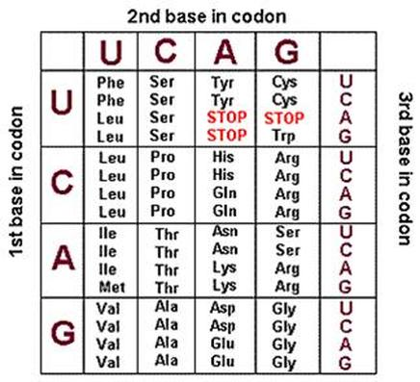
- Draw nucleotide base and label the sugar, phosphate, and base.

