Structure and Function of
3
Life
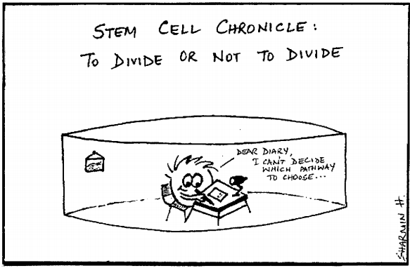

GVC Bio 2- Students will learn about organic macromolecules, organelles, cells, tissues, organs, organ systems, and homeostasis. How cells cycle matter and the flow of energy.

