Remediation 4.4 ABCDE Energy
Use the images on this page to fill in the chart for the 8 forms of energy.
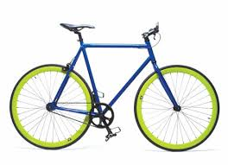  Bicycle | 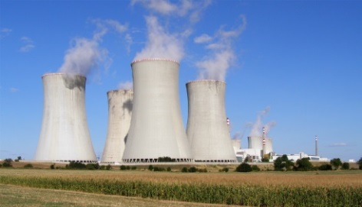  Power Plant | 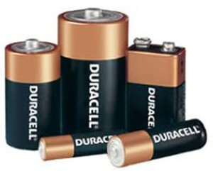  Batteries
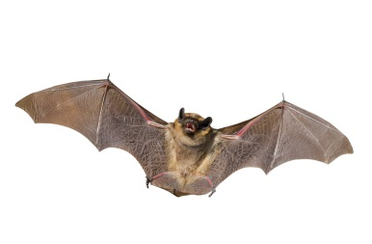  Bat | 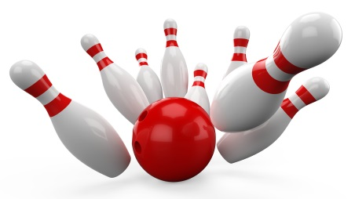  Bowling Pins and Ball | Bell
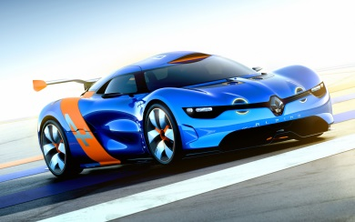  Car | 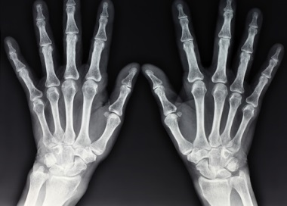  X-ray | 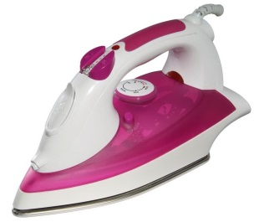  Iron
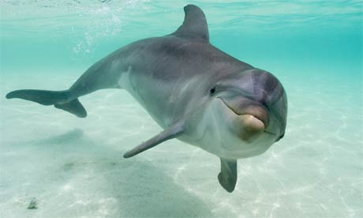  Dolphin | 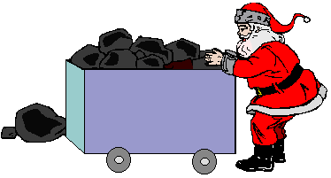  Coal | 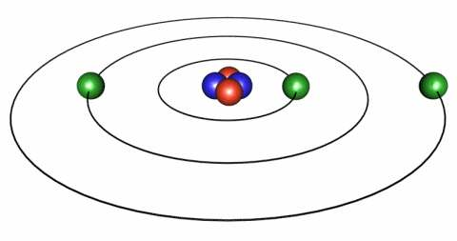  Electrons
Fishing | 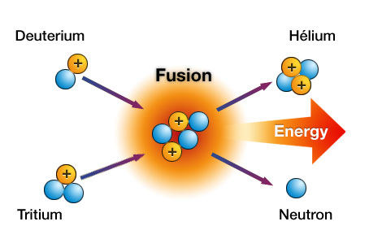  Atoms Fusing | 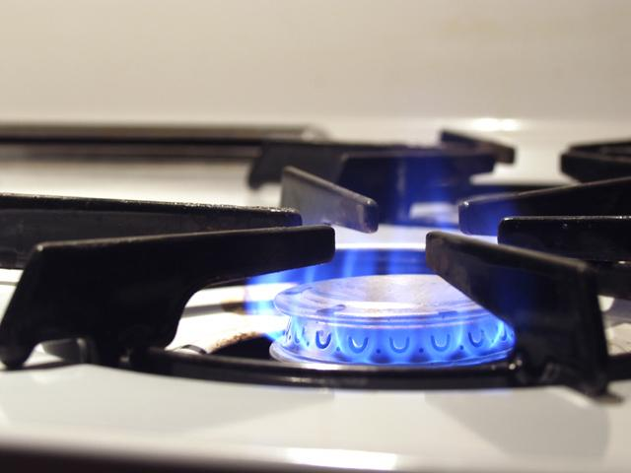  Gas Stove
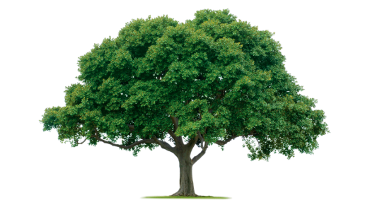Tree | 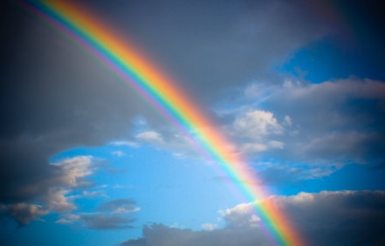  Rainbow | 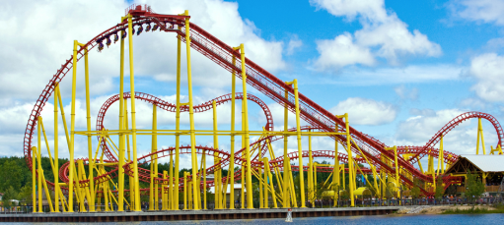  Roller Coaster
Name: _______________________
Remediation 4.4 ABCDE Types of Energy
Pick from the following 8 types of energy to fill in the chart.
Chemical, Nuclear, Gravitational, Radiant, Electrical, Mechanical, Sound, Thermal
Object | Type of Energy | Why?

Label the following as KE (Kinetic Energy) or PE (Potential Energy).
_____ a moving skateboard _____ a rock at the edge of a cliff _____ a glass of milk
_____ gasoline _____ a dry cell battery _____ an acorn hanging on a tree
_____ a person climbing a latter _____ a piece of celery _____ blowing wind

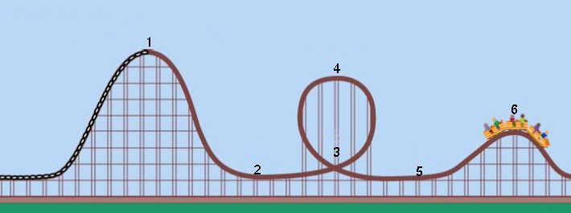
Which positions on the roller coaster show:
Potential energy ___________________
Kinetic energy _____________________

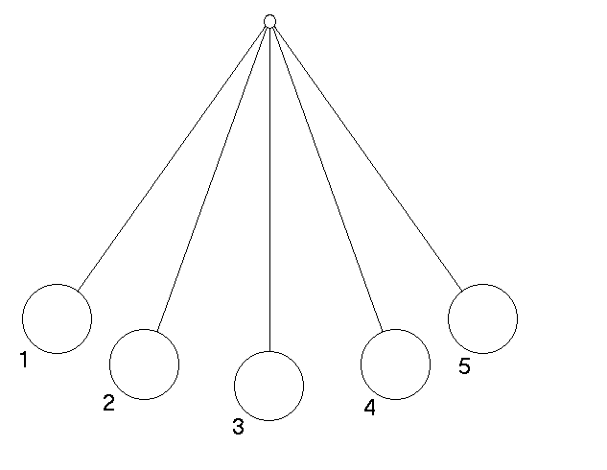
Which positions on the pendulum show:
Potential energy ________________________
Kinetic energy __________________________

Match the organ to the type of energy it senses.
- Ear 1. Heat
- Nose 2. Light
- Skin 3. Sound
- Eye

