Name: ______________________
Period:_______
Reaction Rates Wheel

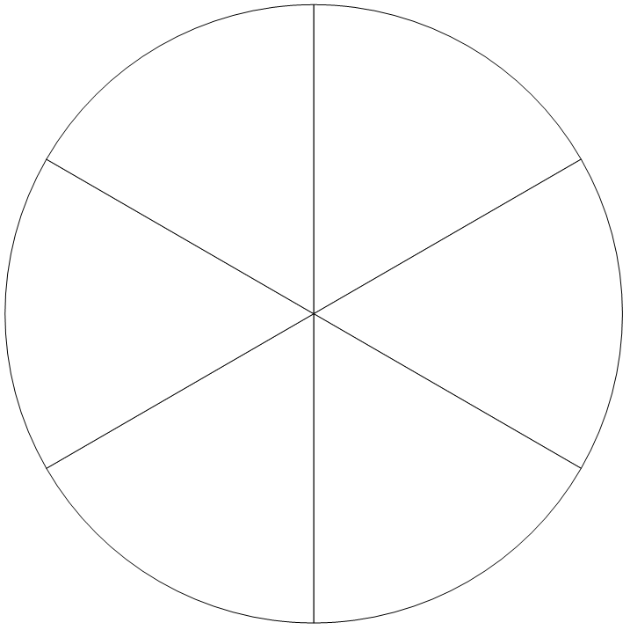

Remediation 1.4 ACD- Reaction Rates Wheel
Below are instructions on how to complete the Reaction Rates Wheel.
- The other side of this page is your reaction rates wheel.
- Cut out the front circle for the reaction rates wheel (on a separate sheet of paper).
- Label the front circle “Reaction Rates” and decorate.
- Attach the two circles together through the center using a brad.
- On the outside of the reaction rates wheel, label each section with the different things that can impact reaction rates…
- Temperature
- Concentration
- Surface Area
- Agitation
- Pressure
- Catalysts
- Then, write the definition, explain how it can impact the reaction, and draw a color picture for each word in the appropriate section.

