Name: Period:
3
Nutrition Labels
You are what you eat. What does that mean? If you eat a cow are you a cow? Eating a salad makes you more of a plant? In our society we have nutrition labels to help inform us of what our food is made up of. How much of what is inside that food?
Look at this nutrition labels and pay special attention to what is presented.
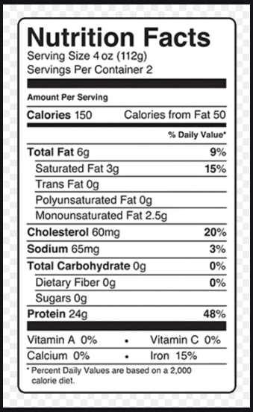
- What are the bolded terms under the words ‘Nutrition Facts’? There are six terms.

- What are the different measurements used to present the amounts of the terms? Try to find at least five.
- The percentages given are for a daily recommended amount based on the number of calories eaten. How many calories for the diet they suggest?
- How many calories should you be eating to maintain a healthy, fully functioning body? To find out you need to find your body mass index.

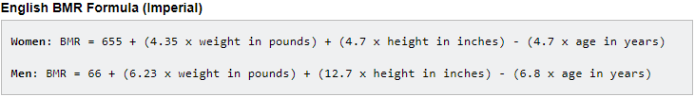
Now, you can use your body mass index to discover the amount of calories you should (about) be eating. * Consult your doctor with this information before using it in your daily diet.

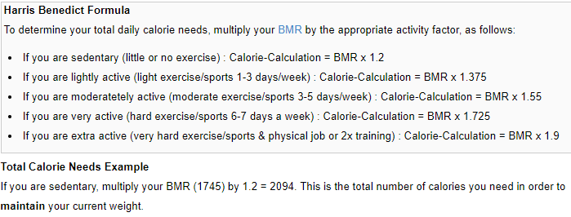

4. Continued…So what is your daily number of calories? calories.

Remember, this is the total number of calories you need in order to MAINTAIN your current weight.

5. Let’s look at some nutrition labels and investigate. From each label write down how much many calories there are and how much fat, carbohydrates, and proteins there are. Decide if this is something you should eat daily, as a snack once in a while, or if you should not eat this at all

Name of Food:
A. Calories
B. Fat
C. Carbohydrates
D. Protein

Name of Food:
A. Calories
B. Fat
C. Carbohydrates
D. Protein

Name of Food:
A. Calories
B. Fat
C. Carbohydrates
D. Protein

Name of Food:
A. Calories
B. Fat
C. Carbohydrates
D. Protein

