Heredity  Gregor Mendel  ____________________  ____________________  Mendel’s Studies  Experiment 1  Law of Segregation | 46  - The __________ of _____________ from parent to offspring  - __________ _________ “Father of Genetics”  - late 19th century  - experiments with _________ ______  - Austrian monk  - described the __________ of _____________  - significance of work recognized in 20th century  - ________ know “__________”  - transferring _________ from the ________ part of one flower to the ___________ part of another flower.  - ___________ will grow into plants with a desired trait  Example: yellow flowers.  - What people thought during Mendel’s time  - Offspring are a "______" of their _____________  - Example: if a pea plant had one _______ parent and one ______ parent, that pea plant would be of ____________ height. The offspring would then pass on heritable factors for medium sized offspring.  Flower Color Flower Position on Stem Stem Length Pod Shape Pod Color Seed Shape Seed Color  Violet-red (Purple) Axial ________ Inflated Green Round Green  White Terminal Short Constricted ___________ Wrinkled yellow  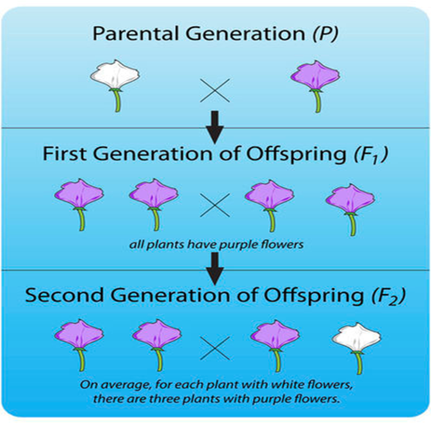  • _____-characteristic _______________  • ____- characteristic _________ ___ again (75%)  • There are two factors controlling a given characteristic  • One _____________  • These factors separate and go to different gametes  • Are different characteristics __________ ____________?  • example, are purple flowers and tall stems always inherited together?
____________________  Law of independent assortment  Probability  Linked Genes  ___________________  Genotype and phenotype | 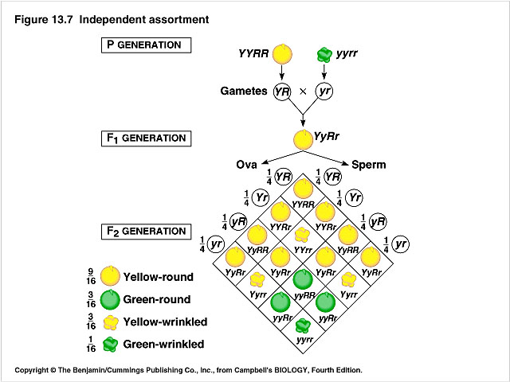  - factors controlling different characteristics are __________ _________ of each other.  - If a parent has one ___________ and one ____________ factor for a trait, then _____the time the dominant factor will be ________ ___, and ______ the time the ___________ factor will be passed on.  - Mendel observed ____ dominant: recessive in his ____ generation  - ____________ ______- genes that are ______ _______ on a chromosome, and are packaged into the ____________ together.  - tend to be inherited together because they are located on the same chromosome.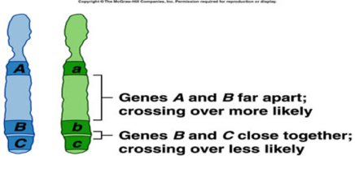  - a chart that allows you to easily determine the __________ _____________ of different genotypes in the offspring of two parents.  - ______________ means that there is one dominant allele and one recessive allele.  - ______________ means that the alleles are the same; either both are dominant or both are recessive.  - A dominant _______ shows up ¾ of the time.  - A ___________ allele shows up ¼ of the time.  - The gametes produced by the male parent are at the_____ of the chart, and the gametes produced by the female parent are along the ______.  - The different possible combinations of alleles in their offspring are determined by filling in the ____________square with the correct letters (alleles).  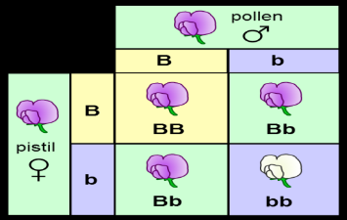  - __________- genes that are inherited from parents  represented by_________, one letter for each gene  - ____________-__________ _____________ of the genotype  Example: a phenotype would be ________ _____________.  - You can _________ the percentages of phenotypes in the offspring of this cross from their ___________.  - B is dominant so ____ or _____ genotype will have the purple-flower phenotype.  - ____ genotype will have the white-flower phenotype.  three out of four (75 percent) have purple flowers and one out of four (25 percent) have white flowers.  - These are the same percentages that Mendel got in his first experiment.  