Motion Final Review
- In comparison to the wave below, draw a sound wave that has high pitch and loud sound volume.

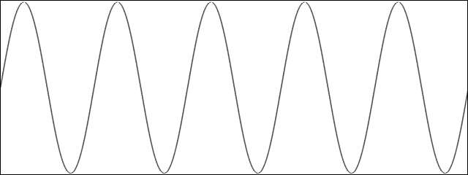

- From the wave you drew above, explain what properties of waves cause high pitch and loud sound volume.
The sound of a wave: | High Pitch | Loud Sound Volume
Properties of waves:

Give an example of energy spreading away from an energy producing source and explain about it. | Draw a picture of your example with the waves showing the spread of energy away from the energy producing source.
a. | b.

Draw Convection Currents | a.
Explain how heat is transferred in Convection Currents | b.

Name: _________________________________________

- Write a sentence describing what happens to the gravity between the two solid spheres as they approach each other.

- If an astronaut weighed 175 pounds on Earth, he would have weighed only 29 pounds on the moon. If his mass on Earth is 80kg, what would his mass be if he is on the moon?

Use the following information for the next two questions.

Students wanted to see the effect different surfaces had on pulling a 500 gram wooded block up an inclined plane with mechanical advantage of 2.
They used the same inclined plane and covered it with sand paper, carpet and wax.

- A controlled variable in this experiment is ______________________

- Classify the surfaces as having the least friction to greatest friction and explain your reasoning for why.
Surface: | Most friction OR Least Friction | Explain your reasoning for why you chose that.
Wax
Sand Paper

- Select three machines you think have had the most impact on your life. Justify your choices by describing the work each machine has accomplished and by predicting what the world might be like without them.
Machine | Describe the work done by the machine | Predict what the world might be like without it
1.
2.
3.

- A ball is thrown into the air as shown in the picture below. Please label each of the following positions with one of the following:
- Greatest potential energy
- Greatest kinetic energy
- Potential energy turning into kinetic
- Kinetic energy turning into potential
A.

B.

C.

D.

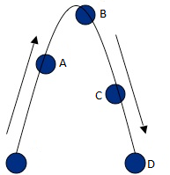

The diagram below shows how energy is transformed in a power plant.
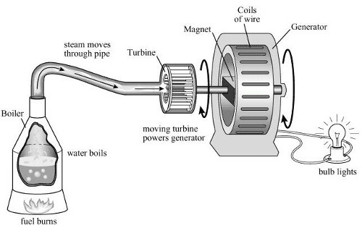
During the entire process, energy is transformed from one form to another several times.

Identify four places in the diagram where an energy conversion is taking place. | For each location describe the type of energy present before the conversion | For each location describe the type of energy present after the conversion
1.

2.

3.

4.

