Meiosis Flipbook
37
Create a flipbook to illustrate the phases of Meiosis.
Use pages 324-325 in the “Parrot Textbook”.
The front should look like this… (Decorate as you wish)
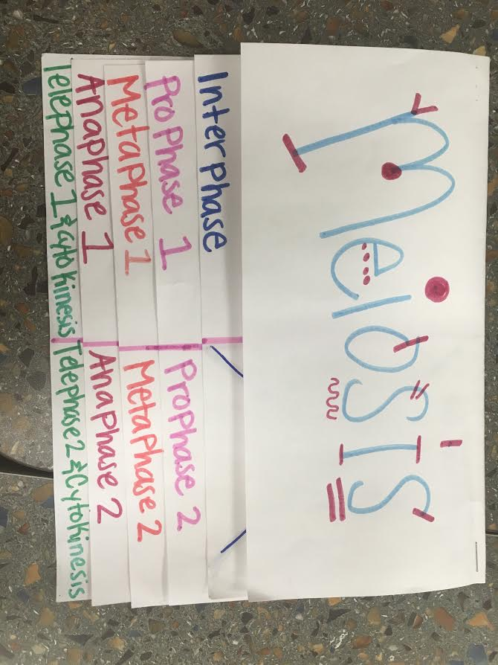
Inside flaps should look like this…
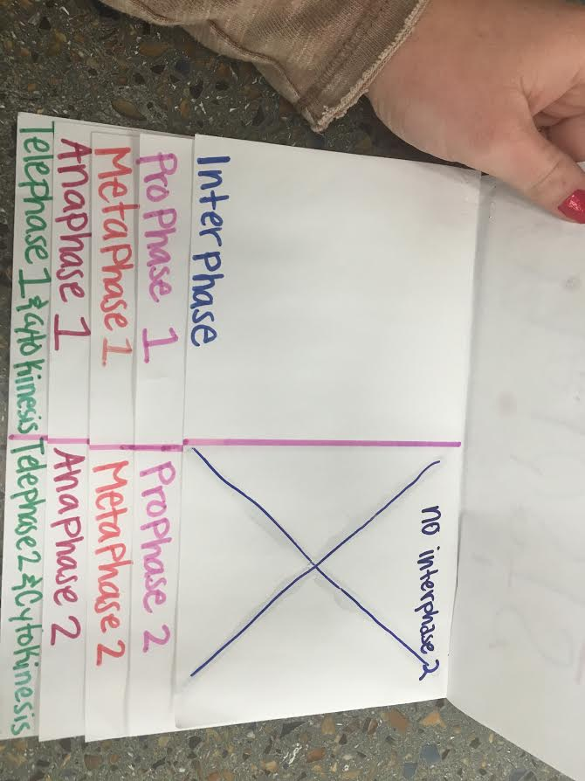

- Colored (keep the same color for each organelle throughout the flipbook)
- Label organelles involved in phase (optional)
- Write a description of what is happening in that phase
- Hole-punch flipbook (2 holes) and place in front of this page in binder

