Matter Unit Final Review
- A cube of sugar has the following properties. Mark each of the properties as a Physical Property (P) or Chemical Property (C)
Properties of a cube of sugar | Physical (P) or Chemical (C)
1. Mass = 2 grams
2. Density = 8 g/cm³
3. Burns when heated
4. Shaped like a square

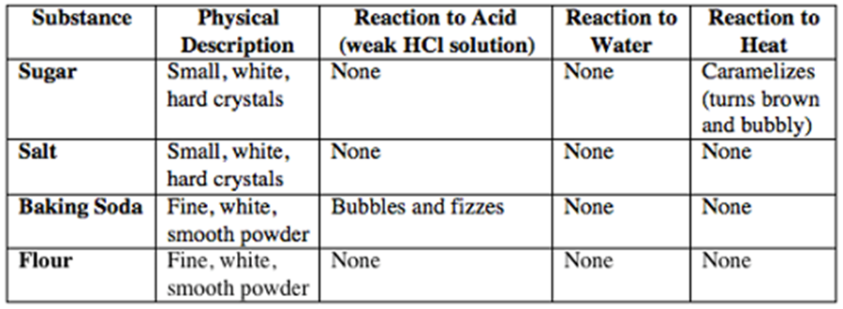
Which 3 tests measured chemical properties?

- Circle Which of the following are the chemical properties of iron?
It can melt
It can rust
It can bend
It can break into pieces
It is non-flammable

- List 3 Physical Properties of a Tennis Ball.

5. List the 4 characteristics of a chemical change.
1-
2-
3-
4-
6. Suppose you place several ice cubes in a glass of water. Describe at least two physical changes that might occur over a period of time.

Name: ___________________________________
7. How are a camp fire burning and cellular respiration in living things similar?

8. Why does a liquid change to gas when heated?

9. 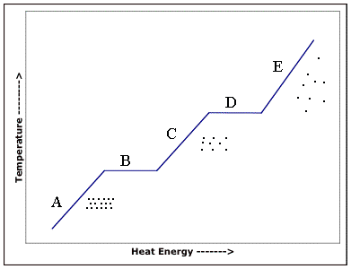
Circle all letters where a phase change is occurring.

10.
Describe a chemical change you have observed during which heat energy was given off. | Explain how you would gather evidence that energy was released.
a. | b.

11. Circle all examples of common chemical reactions
  - Evaporation
  - Rust
  - Combustion
  - Photosynthesis
  - Respiration
  - Condensation

12.
Give an example of when heat is given off in a chemical change. | Explain how heat can be given off in a chemical change. | Give an example of when heat is taken in during a chemical change. | Explain how heat can be taken in during a chemical change.
a. | b. | c. | d.

13. The reactants of Respiration have 6 Carbons, 12 Hydrogen and 18 Oxygens. How many atoms of Carbons, Hydrogens and Oxygens should the product of Respiration have? Explain the reasoning for your answer.

14. Students wanted to test which method (stirring, heating or crushing) would increase the rate of dissolving an effervescent tablet the best. Students timed the seconds it took for the tablet to dissolve. See the data in the chart below.
Control | Stirring | Heating | Crushing
57 seconds | 45 seconds | 20 seconds | ?

Predict the seconds it would take for a crushed effervescent tablet to dissolve. Explain the reasoning for your prediction.

15. An engineering company wants to test 3 different bridge designs to see which design will hold the greatest load. The designs are: A-Steel, B-Wood, or C-Steel/Wood. Identify the following parts of the experiment as if you were to plan out and conduct the test on your own.
- What is a possible “Hypothesis”?

- What is the “Independent variable”?

- What is the “Dependent variable”?

- What are the “Controlled variables”?

- What visual format would you use to display and summarize your data so it can be analyzed and a conclusion can be made?

