Lab-Enzyme Amylase Action on Starch | 9
In this experiment you will observe the action of the enzyme amylase on starch. Amylase changes starch into a simpler form: the sugar maltose, which is soluble in water. Amylase is present in our saliva, and begins to act on the starch in our food while still in the mouth. Exposure to heat or extreme pH (acid or base) will denature proteins. Enzymes, including amylase, are proteins. If denatured, an enzyme can no longer act as a catalyst for the reaction.
Benedict's solution is a test reagent that reacts positively with simple reducing sugars like maltose, but will not react with starch. A positive test is observed as the formation of a brownish-red cuprous oxide precipitate. A weaker positive test will be yellow to orange.
MATERIALS:
Cornstarch
Distilled water
Saliva
Vinegar
Benedict's qualitative solution
3 graduated cylinders
beaker
Stirring rod
3 test tubes
Test tube rack
Tape and Marker
Hot Water Bath
PRE-LAB: Add 1g of cornstarch to a beaker containing 100ml of cold distilled water. While stirring frequently, heat the mixture just until it begins to boil. Allow to cool. (This has been done for you.)
PROCEDURE:
1. Fill the beaker about ²/₃ full of water and place on the hot plate for a hot water bath. Turn your hot plate all the way up AFTER WATER BOILS TURN IT DOWN TO A SIMMER.
2. Mark 3 test tubes A, B and C. "Spit" between 1 and 2 mL of saliva into each test tube.
3. Into tube A, add 2 mL of vinegar. Into tubes B and C, add 2 mL of distilled water. Thump the tubes to mix.
4. Place tube B into the boiling water bath for 5 minutes. After the five minutes, remove from the bath, and place back into the test tube rack.
5. Add 5 mL of the starch solution to each tube and thump to mix. Allow the tubes to sit for 10 minutes, occasionally thumping the tubes to mix.
6. Add 5 mL of Benedict's solution to each tube and thump to mix. Place the tubes in the hot water bath. The reaction takes several minutes to begin.
OBSERVATIONS:
Tube A: Starch + saliva treated with vinegar (acid)
Was the test positive or negative?
What does this indicate?
Tube B: Starch + saliva and water, treated in a boiling water bath
Was the test positive or negative?
What does this indicate?
Tube C: Starch + saliva
Was the test positive or negative?
What does this indicate?
QUESTIONS:
1. What is the function of an enzyme?
3. What is a common suffix found at the end of most biological enzymes?
4. Most enzymes are macromolecules called ________________.
5. What was the purpose of placing one test tube in a hot water bath?
6. What happens to enzymes in your body whenever you run a fever?
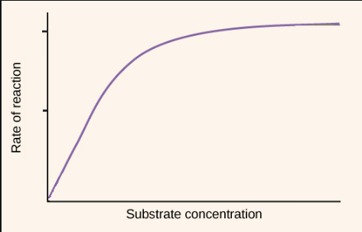
6. In the graph, draw another line depicting how an enzyme would behave under high acidity. Draw another line depicting enzymes working under high temperatures.

