Name: _____________________________
Intervention 1.3 BC
States of Matter: Solids, Liquids, and Gases
Cut the pictures from “pictures to cut and paste” and paste them on this page.
Solids | Liquids | Gases
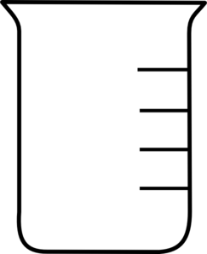  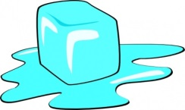 | 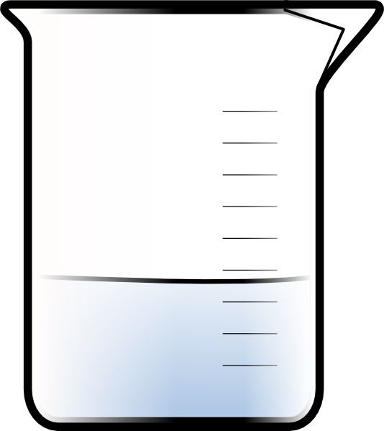

Heating Curve of Water
The diagram below is a plot of temperature vs. time. It represents the heating of what is initially ice at -10ºC at a near constant rate of heat transfer.
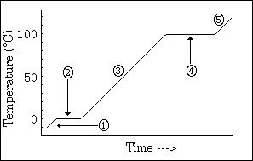

- a)What phase or phases are present during segment (1) _______________________________________
b) What phase change, if any, is taking place? _____________________________________________

- a)What phase or phases are present during segment (2) _______________________________________
b) What phase change, if any, is taking place? _____________________________________________

- a)What phase or phases are present during segment (3) _______________________________________
b) What phase change, if any, is taking place? _____________________________________________

- a)What phase or phases are present during segment (4) _______________________________________
b) What phase change, if any, is taking place? _____________________________________________

- a)What phase or phases are present during segment (5) _______________________________________
b) What phase change, if any, is taking place? _____________________________________________

Pictures to cut and paste:
REMOVE HEAT ENERGY
CONDENSATION
REMOVE HEAT ENERGY
BOILING/EVAPORATION
ADD HEAT ENERGY
ADD HEAT ENERGY
MELTING
FREEZING
Molecules move around slowly
Molecules cannot move Molecules vibrate in place
Molecules move around freely
Molecules are close together
Molecules are widely separated
Molecules are very close together

Pictures to cut and paste:
REMOVE HEAT ENERGY
CONDENSATION
REMOVE HEAT ENERGY
BOILING/EVAPORATION
ADD HEAT ENERGY
ADD HEAT ENERGY
MELTING
FREEZING
Molecules move around slowly
Molecules cannot move Molecules vibrate in place
Molecules move around freely
Molecules are close together
Molecules are widely separated
Molecules are very close together

