Genetics Review
135
GVC 4- Students will understand that genetic information coded in DNA is passed from parents to offspring by sexual and asexual reproduction. The basic structure of DNA is the same in all living things. Changes in DNA may alter genetic expression.

- What 2 processes allow for offspring to inherit chromosomes from each parent to create new combinations.

- Genes give us variation, list 2 ways that this variation can be seen in humans.

Explain one advantage of sexual reproduction | Explain one disadvantage of sexual reproduction | Explain one advantage of asexual reproduction | Explain one disadvantage of asexual reproduction

- Mutations can be used to produce desirable traits. Give an example of a desirable trait that might be achieved. How could this be considered a bioethical issue?

- Mendel discovered that genes are segregated, what does that mean?

- Mendel also assumed that every trait was inherited separately or randomly from every other. We now know that is there is an exception to that, what is it?

- 2 corn plants are bred and the trait for seed color is observed as a monohybrid trait. The two possible colors are yellow and white. Both plants are heterozygous yellow.
Complete the punnett square below.

Phenotypic ratio:

Genotypic ratio:

Dominant trait:

Recessive trait:

- Complete the pea plant dihybrid cross for seed color and seed texture. The first plant has green seeds and is wrinkled (rrtt), the second plant has yellow seeds and is also wrinkled (Rrtt).
Complete the punnett square below.

Phenotypic ratio:

Genotypic ratio:

Dominant traits:

Recessive traits:

- Complete the following pedigree chart, determine what type of trait the chart is showing.
(autosomal recessive, autosomal dominant, sex-linked recessive, sex linked dominant)

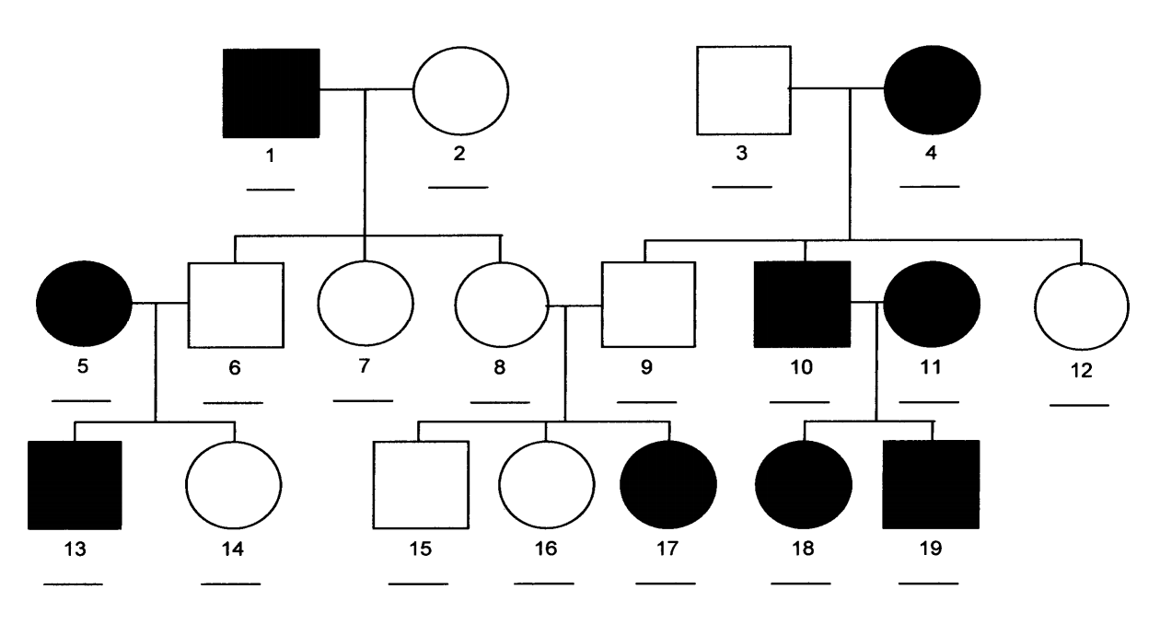
10. What is the genotype of the female sex chromosomes? ________ What is the genotype of the male sex chromosomes? ________ What chromosome are sex-linked traits found on? ____

11. Give an example of each of the following.
Codominance-
Incomplete dominance-
Sex-linked trait-

12. What are advantages of selective breeding?

13. Give an example of a “bioethical issue,” what does that mean?

14. Label the DNA nucleotide below. (hint: a nucleotide is a small section of DNA or RNA)
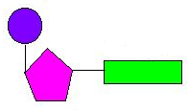
15. Compare and contrast RNA and DNA.

16. Complete the strand with complimentary base pairs for DNA replication. (DNA->DNA)
A T C C T G T A A A A T G T G T G C

17. DNA replication creates new DNA, what is it needed for?

18. Complete the strand with complimentary base pairs for transcription. (DNA->RNA)
G C G T G A A T G T C T G A T A T G C

19. Complete the mRNA strand with complimentary tRNA for translation. (RNA->RNA)
U G C U A G A C U G G U G C A C A U G

20. What happens next in translation?

20. What is a mutagen? Give an example.

