Extension: Cells
29
Using the word bank provided, label the parts of a microscope (you may have to use the internet to research!)
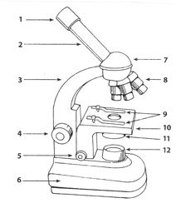
1.
2.
3.
4.
5.
6.
7.
8.
9.
Base Light Diaphragm Stage Stage Clips Objective Lenses Eye Piece Eyepiece Tube Arm Fine Focus Course focus Head
10.
11.
12.
Travel to any 6 of the 9 lab stations, pick one slide at each and complete the following. No more than 4 people at a station at once!
Station ___:
- What slide did you select?
- Was it showing a phase of mitosis? If so, which phase?
- Is the cell autotrophic or heterotrophic?
- Sketch a detailed picture of what you see

Station ___:
- What slide did you select?
- Was it showing a phase of mitosis? If so, which phase?
- Is the cell autotrophic or heterotrophic?
- Sketch a detailed picture of what you see

Station ___:
- What slide did you select?
- Was it showing a phase of mitosis? If so, which phase?
- Is the cell autotrophic or heterotrophic?
- Sketch a detailed picture of what you see

Station ___:
- What slide did you select?
- Was it showing a phase of mitosis? If so, which phase?
- Is the cell autotrophic or heterotrophic?
- Sketch a detailed picture of what you see

Station ___:
- What slide did you select?
- Was it showing a phase of mitosis? If so, which phase?
- Is the cell autotrophic or heterotrophic?
- Sketch a detailed picture of what you see

Station ___:
- What slide did you select?
- Was it showing a phase of mitosis? If so, which phase?
- Is the cell autotrophic or heterotrophic?
- Sketch a detailed picture of what you see

