Evolution Review
136
GVC 5- I can understand that biological diversity is a result of evolutionary processes.

- What effect does stress on an ecosystem have on natural selection?

2.
Give an example of a change in the environment that was not done by man. | Give an example of a change in the environment that was done by man.
- How does biodiversity help a species ability to adapt?

4.
Give an example of reproductive isolation. | How can this lead to speciation?

- How has selective breeding had an impact on the appearance and usefulness of farm animals?

- List 4 evidences that support biological evolution over time.

- What is the role of mutation and recombination in evolution?

In general, how final are scientific conclusions? | What impact do natural laws have on scientific conclusions? | Explain the process that a new “theory” has to go through to be accepted in the scientific community. | What happens to an accepted theory if new information is discovered that doesn’t fit?

8.
In relation to evolution, what observation did Darwin make about the Galapagos finches? | Based on that observation, what inference did he make?

- Identify bird X. _____________________________________
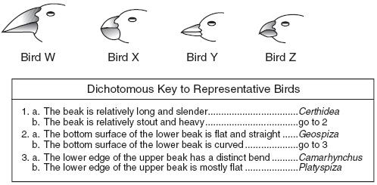
- What is a field guide and who is it useful to?

- List the classification systems in order from broadest to most specific.

- Circle the two groups that are most closely related

