86
Evolution
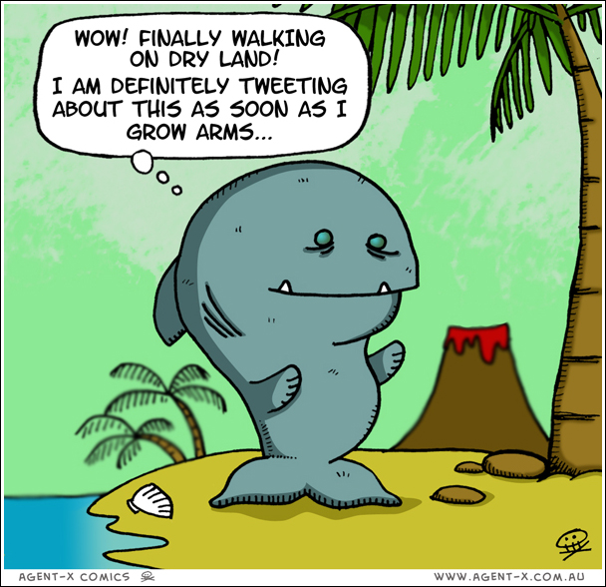
GVC 5
Students will understand that biological diversity is a result of evolutionary processes.
