ENZYME HAND PRINT ACTIVITY
Step 1: Spread your hand out as wide as possible so that all of it still fits on the paper. Trace around your hand so that your hand print is on the paper
Step 2: Label the center of your hand with the title “5 Facts About Enzymes”
Step 3: Number the top of each of your fingers, in order, from 1 to 5 with large numbers. It does not matter which side you start on.
Step 4: Write within each of the fingers and thumb the 5 facts that are true of ALL enzymes.
1. Enzymes are HIGHLY SPECIFIC!
2. Enzymes are REUSABLE!
3. Enzymes are BIOLOGICAL CATALYSTS!
4. Enzymes are FRAGILE – ABLE TO BE DENATURED EASILY! !!!!! The most important feature to an enzyme is its SHAPE !!!!!!!!
5. Enzymes work in ONE DIRECTION OR THE OTHER, BUT NOT BOTH!
Step 5: Just outside the fingers, EXPLAIN WHAT EACH OF THESE STATEMENTS MEANS!

Step 6: On this side of the paper, draw a very large triangle the full size of the paper. Then, turn the paper upside down and draw a smaller triangle inside the big triangle. Then, turn the paper back over and fill in the center with: “THREE THINGS THAT WILL DENATURE AN ENZYME”
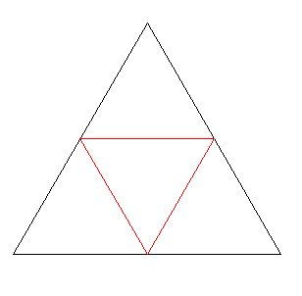
Step 8: List the three factors that affect the activity of the Enzyme in each of the three corner triangles.

