Name_________________________
2
Period_____________
ECOLOGY UNIT
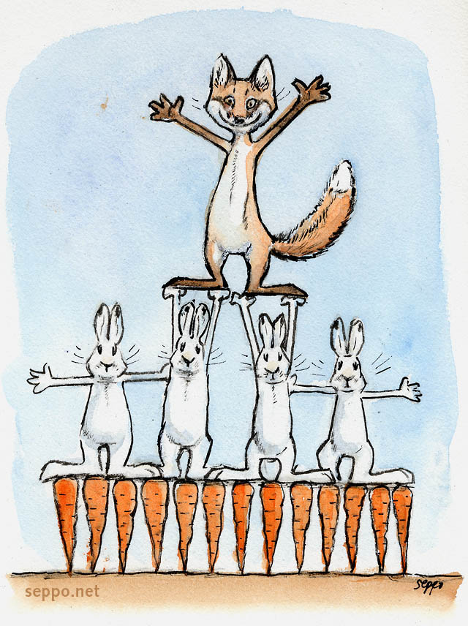
GVC: Students will understand that living organisms interact with one another and their environment.

