Earth Unit Final Review
- Complete the chart, adding in the names of the three main types of rocks where they apply.
Description of Rocks: | Made by weathering, erosion &cementation | Made by melting into magma and cooling | Made by burial, heat and pressure
Rock Types: | a. | b. | c.

- Choose the Grand Canyon, Mount Everest, or another example of your choice. Please explain how the example you selected illustrates or shows how small changes over time can add up to major changes to Earth’s surface.

- Describe the sequence of events for a Sedimentary Rock to become an Intrusive Igneous Rock.

- If you had a rubber band, how could you use it to model the process of earthquake formation? Please describe and draw your explanation. Remember to explain how matter and energy are changing during the process?

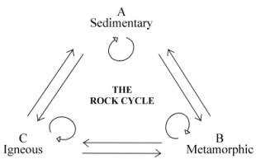
- Using this diagram, list two events that must happen for rock to cycle from point B to point C?

- Fossils of freshwater fish and dinosaur swim tracks are found in St. George. What does this evidence tell us about what St. George use to look like in the past?

Name: ______________________________________________
- Draw a model of the rock cycle and label the diagram with the 3 types of rock and the processes or events that cause them to change from one form to another.

- Use the chart to classify this mineral.
Mineral | Hardness Rating | Streak | Reaction with Acid
Halite | 2.5 | Clear/Gray | No
Calcite | 3 | Clear/Gray | Yes
Fluorite | 4 | White | No
Dolomite | 3.5 | White | Yes
Augite | 5 | Gray/Green | No

- This unknown mineral does react to acid and has a white streak. The unknown mineral is_________________
- This unknown mineral does not react to acid and has a green streak. The unknown mineral is _________________

- Explain the role of wind and water as a force of energy that causes rocks to change over time.
- A fossil is any remains or traces of an ancient organism. Circle “Yes” or “No” by the type of rock depending if it can contain fossils and write a sentence explaining why you chose that answer.
Rock Type: | Can this rock contain a fossil?  “Yes” OR “No” | Explain why:
Sedimentary
Igneous
Metamorphic

- Folding, faulting, igneous intrusions and erosion are some things that disrupt the layers of Earth from being oldest on the bottom, youngest on the top. Identify each picture and name the disruption: folding, faulting, igneous intrusions and erosion.
Picture of disruption: | Name of disruption:
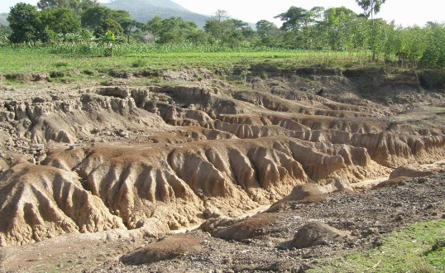 | a.
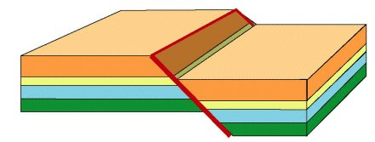 | b.
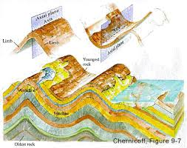 | c.
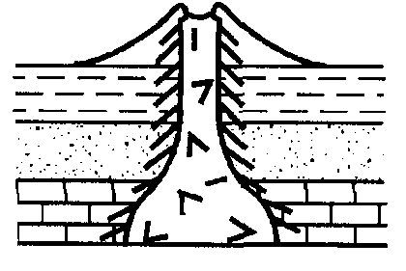 | d.

- Propose why more recently deposited rock layers are more likely to contain fossils resembling existing species than older rock layers.

13. Give the 4 characteristics of minerals.

- Complete the chart by drawing, listing characteristics, or labeling the main types of volcanoes.

Name of Volcano | Characteristics | Picture
Shield

 |  | 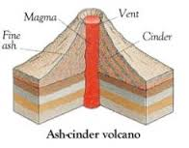
- Formed from repeated explosive and nonexplosive eruptions
- Wide at the base, but get steeper near the top.
- The most common type of volcano.
- Mt St Helens and Mt Fuji are examples

- Draw and label a diagram demonstrating the Law of Superposition.

