Classification Reading Guide
106
Use pages 264-274 in your “bee” textbook.
- Define classification.

- What are two ways that you could classify skittles?

- Who is the first scientist that we know of to develop a classification system?
- Who developed the classification system that we use today?
- Define Taxonomy.

- Describe binomial nomenclature.

- Give an example

- A binomial nomenclature includes 2 names, what are they?

- How many domains are there?(this is the least specific category) List them.

- How many Kingdoms are there?(this is the next least specific category) List them.

- Define species.

- Fill in the chart below with the classification categories and the descriptions of the organisms included in them for Homo sapiens.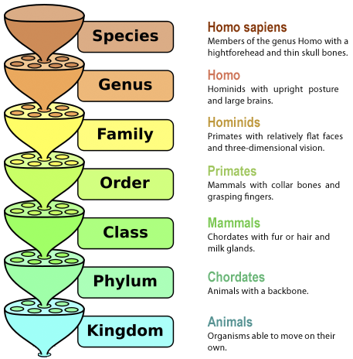
- Animals are in domain________________ and kingdom ________________________. Animal cells are known as _____________________ cells. They have a nucleus and other ______________-bound organelles. Unlike plants and fungi, they lack a cell __________.
- Most animals share 3 characteristics that distinguish them from other organisms, what are they?

- Members of the animal kingdom are divided into more than 30 phyla, give an example of a phyla and the type of organisms it includes.

- Compare and contrast vertebrates and invertebrates.

- List 4 important animal adaptations that have evolved from invertebrates.

